MegumaGold Corp.

Management’s Discussion and Analysis

For the Three-Month Period Ended June 30, 2020 and 2019

This management's discussion and analysis provides an analysis of our financial situation which will enable the reader to evaluate important variations in our financial situation for the period ended June 30, 2020, compared to the period ended June 30, 2019. This report prepared as at August 28, 2020 intends to complement and supplement our condensed interim consolidated financial statements (the “financial statements”) as at June 30, 2020 and should be read in conjunction with the financial statements and the accompanying notes. The financial statements of subsidiaries are included in the consolidated financial statements from the date that control commences until the date that control ceases.

Our financial statements and the management's discussion and analysis are intended to provide a reasonable base for the investor to evaluate our financial situation.

Our financial statements have been prepared using accounting policies consistent with International Financial Reporting Standards (“IFRS”). All dollar amounts contained in this MD&A are expressed in Canadian dollars, unless otherwise specified.

Where we say “we”, “us”, “our”, the “Company” or “MegumaGold”, we mean MegumaGold Corp. and/or its subsidiaries, as it may apply.

OVERVIEW and DESCRIPTION of BUSINESS

MegumaGold Corp. (“the Company” or “MegumaGold”) was incorporated pursuant to the Business Corporation Act (British Columbia). The Company is a listed issuer on the Canadian Securities Exchange (“CSE”) under the symbol "NSAU", the Frankfurt Stock Exchange under the symbol FWB: 2CM and on the United States OTC stock market’s OTC Pink, under the symbol NSAUF. The Company’s registered office is at 789 West Pender Street, Suite 810, Vancouver, British Columbia, V6C 1H2, Canada and its head office is located at Suite 2630-1075 West Georgia Street, Vancouver, British Columbia, V6E 3C9, Canada.

The Company is engaged in the business of acquiring, exploring and developing natural resource properties, with a focus on precious mineral properties/projects which have the potential for both near-term cash flow and significant exploration upside potential. The Company is considered to be in the exploration stage as it has not placed any mineral properties into production.

CORPORATE DEVELOPMENTS AND SIGNIFICANT TRANSACTIONS AND FACTORS AFFECTING RESULTS OF OPERATIONS

Proposed Transaction – Osprey Gold Development Ltd:
On June 8, 2020, the Company signed a Definitive Agreement with Osprey Gold Development Ltd. Pursuant to the terms of the Definitive Arrangement Agreement, the Company will acquire all of the issued and outstanding shares of Osprey. Each shareholder of Osprey will receive such number of common shares of the Company as is equal to the product of the number of Osprey shares held by such shareholder at an exchange ratio which equals one of the Company’s shares per two Osprey shares outstanding at the closing of the transaction.
The arrangement agreement provides that unexercised Osprey options and share purchase warrants will be assumed by the Company and will: (i) remain outstanding for their full term and (ii), following the closing date of the transaction, entitle the holder thereof to acquire the Company shares in lieu of Osprey shares, in such number and at such exercise price as shall be adjusted based on the exchange ratio inherent in the transaction, and otherwise on the same terms and conditions as existed prior to the transaction.
Osprey will have the right to appoint two members to the board of directors of the resulting issuer, with the total number of members of such board of directors to be initially set at five. Osprey shall also contribute management personnel to the resulting issuer.

CORPORATE DEVELOPMENTS AND SIGNIFICANT TRANSACTIONS AND FACTORS AFFECTING RESULTS OF OPERATIONS (CONTINUED)

      - On May 8, 2020, the Company entered into a Promissory Note (“Promissory Note”) of $75,000 with Osprey. The Promissory Note is non-interest bearing, due on demand and is unsecured.
      - On May 14, 2020 the Company completed and filed a 43-101 Property Technical Report.
- On June 3, 2020, the Company disposed of 13,100,000 share purchase warrants (“Warrants”) of Osprey through private transactions with two arm’s-length parties. Prior to the Dispositions, the Company beneficially owned 6,423,000 common shares (“Shares”) and 13,100,000 Warrants of Osprey. During the period ended June 30, 2020, the Company sold 3,177,000 common shares of Osprey for gross proceeds of $192,443 and recognized a gain on sale of $49,478.
- The Company completed regional target delineation field programs in the Eastern Nova Scotia gold fields which included a ground geophysical survey, geochemical (“Till”) and soil surveys along with induced polarization (IP) The current till program included 250 sample sites, in conjunction with the tills sampling work the a ground VLF-EM program was conducted by use of portable transmitter station and was designed to cover 80km lines. Soil geochemical work included 1,100 sample sites and was completed over an IP grid covering 25 km lines.
- In November of 2019 the Company elected not to exercise its option on its Ecum Secum and Higgins Brooke projects as the Company continues to pursue key target areas in Nova Scotia.

- On November 29, 2019, the Company announced additional soil geochemical results with elevated arsenic and gold values for its Touquoy West Project. The Company has identified large gold-arsenic anomalies trending along the west extension of the Moose River anticline which hosts St. Barbara Ltd.’s open pit Touquoy Gold Mine. The preliminary results define three well- developed soil anomalies with elevated values ranging from 5 to 34 parts per billion within a halo of anomalous arsenic values ranging from 30 and 900 parts per million. The Company intends to continue to review and conduct work on this project.

- Pursuant to the promising results announced on November 29, 2019, the Company continues to review potential gold projects. The Company has been successful in defining large arsenic in soil trend that support elevated gold results and the Company is looking to continue evaluating projects west of Touquoy that is on anticlinal strike of St. Barabara’s open pit mine. As a result, the Company entered into an option agreement with Genius Metals Inc.

- On December 4, 2019, the Company entered into an option agreement (“Genius Option Agreement”) to explore and develop licenses 6 licenses covering 1,620 hectares in Nova Scotia (“Property”). The Genius Option Agreement allows the Company to earn up to a 70% interest in 6 mining exploration licenses by satisfying the following conditions:

- Issue 250,000 common shares within 10 business days of signing the Genius Option Agreement (Issued);

- Earn 49.9% interest upon incurring $100,000 in exploration work consisting of ground surveys and pre-drilling target work on or before the 18 month anniversary;

Earn 20.1% interest upon incurring $150,000 in exploration work, including a diamond drilling program on or before the 30 month anniversary. Upon exercising the Genius Option Agreement in its entirety and earning 70% of the Property, Genius will have the option to convert the remaining 30% interest in the Property, into a 2% net smelter royalty.

CORPORATE DEVELOPMENTS AND SIGNIFICANT TRANSACTIONS AND FACTORS AFFECTING RESULTS OF OPERATIONS (CONTINUED)

- On January 31, 2020, the Company entered into a purchase and sale agreement to acquire 203 mining claims adjacent to and on-strike with Meguma Gold’s Greater Goldenville Gold Project (“Goldenville”) in Nova Scotia Canada. Following the acquisition of Goldenville Gold District, the Company has increased its mineral licenses from 240 to 443 mineral claims in the Goldenville Gold District, which scales up the Company’s operating base and exploration portfolio.

- On February 21, 2020 and as of the date of this MD&A, the Company is working on closing a palladium project in British Columbia. The Company acquired 5 mineral claims for a total of 3,067 hectares, located in British Columbia for $125,000 and 6,000,000 common shares.
- On March 11, 2020, the Company announced that, further to its news release dated February 21, 2020, it has closed the acquisition of 5 mineral claims for an arms-length consideration of sum of $125,000 and 6,000,000 fully paid and non-assessable common shares.
Use of proceeds

Flow-through
The Company intends to use the net proceeds of the January and May 2018 flow-through private placements on qualifying Canadian Exploration Expenditures pursuant to the Income Tax Act (Canada), to further explore the Company’s exploration and evaluation assets and initiate a multi-phase exploration program.

Intended use of proceeds of May 2018 Flow-through Private Placements |  | Amount incurred to date June 30, 2020 |  | Variances
Canadian exploration expenditures | $3,565,410 | Canadian exploration expenditures | $2,833,984 | No variances anticipated.
Total | $3,565,410 | Total to date | $2,833,984
Intended use of proceeds of January 2018 Flow-through Private Placements |  | Amount incurred to date June 30, 2020 |  | Variances
Canadian exploration expenditures | $2,205,000 | Canadian exploration expenditures | $2,205,000 | No variances anticipated.
Total | $2,205,000 | Total to date | $2,205,000

As of the date of this MD&A, the Company has begun to use the funds as intended. The Company will use the gross proceeds raised from the private placements to incur qualifying Canadian exploration expenditures on its projects. The Company expects that the exploration expenditures to be incurred in fiscal 2020, will exceed the $3,565,410 flow-through financing renounced in the 2018 taxation year. See Exploration and Development Strategy section.

PROPERTIES

The Company capitalized the following acquisition cost during the period ended June 30, 2020 and for the year ended March 31, 2020:

 | Meguma Project  $ | Cariboo Project  $ | Palladium project  $ | Total  $
Balance, March 31, 2019 | 7,725,374 | 4,400,000 | - | 12,125,374
Acquisition costs | 155,054 | - | 965,000 | 1,120,054
Mining rights | (17,652) | - | - | (17,652)
Assaying | 198,252 | - | - | 198,252
Supplies | 91,194 | - | - | 91,194
Drilling | 172,838 | - | - | 172,838
Geological consultants | 37,038 | - | - | 37,038
Geological surveying | 857,311 | - | - | 857,311
Impairment | (110,990) | - | - | (110,990)
Balance March 31, 2020 | 9,108,419 | 4,400,000 | 965,000 | 14,473,419
Acquisition costs | 20,000 | - | - | 20,000
Assaying | 63 | - | - | 63
Geological consultants | 79,375 | - | - | 79,375
Balance June 30, 2020 | 9,207,857 | 4,400,000 | 965,000 | 14,572,857

During the periods ended June 30, 2020, the Company has centered its exploration focus on the developing Meguma formation of Nova Scotia and has assembled a strategically-positioned tenure of prospective gold zones in Nova Scotia. The Company continues to explore extensively throughout the region and expenditures demonstrate the Company’s objectives. The Company continues to complete geophysics and preliminary drilling to evaluate potential locations of value. Till sampling, ground geophysics and induced polarization programs were later initiated to help define targets of lesser known geological information. See Exploration and Evaluation Strategy for more detail.

OVERALL PERFORMANCE

The Company explores for precious minerals with an emphasis on gold. The Company has no earnings and therefore finances exploration and development activities by the sale of shares. The key determinants of the Company's operating results are the following:

(a) success of its exploration and development programs and putting these into production;
(b) the state of capital markets, which affects the ability of the Company to finance its exploration activities;
(c) the market price of gold and silver; and
(d) political and social issues which have affected and could further affect the ability of the Company to conduct exploration and mine development activities on its projects in Canada.

EXPLORATION and Development STRATEGY
MegumaGold Property

Through its subsidiary 1156219 B.C. Ltd, MegumaGold has 100% interest in, or holds under several option agreements, a total of 247 Mineral Exploration Licences comprised of 6,449 mineral claims (104,396 hectares). The exploration licences that MegumaGold holds in Nova Scotia span a large area of the central and eastern parts of the mainland of the province, including Halifax, Guysborough, Hants, and Colchester counties.
The current land position was staked along the under-explored trends of known gold producing anticlinal structures and the Company estimates that it will control approximately 466 km (total strike length) of gold-prospective anticlines,
which provides the Company with a unique opportunity to control the largest strike-length share of projected anticlines in the province.
EXPLORATION and Development STRATEGY (CONTINUED)
The MegumaGold Properties are mainly situated in Eastern Nova Scotia; specifically, east of the Halifax Regional Municipality (HRM or Halifax), and south of the town of Guysborough. The closest international airport is the Halifax Stanfield International Airport about 25 km north of Halifax. The properties can be easily accessed from secondary highways, such as Highway No. 7 and local roads. All properties are within a 2 to 3-hour drive of the Halifax Regional Municipality (HRM) which has a population of approximately 400,000. From the secondary highways, forestry access roads are normally used to access the mineral claims directly, whether by truck, all-terrain vehicle or by foot, depending on the condition of specific roads or trails. Sheet Harbour (pop. 800) is the largest town in the Eastern Shore area along Highway No. 7 to offer full services, with the villages of Sherbrooke (pop. 400) and Guysborough (pop. 400) providing partial services. The town of Antigonish (pop. 4,400) is located approximately 62 km north of the village of Sherbrooke along Highway No. 104 and is the closest full-service community to the furthest eastern claims in MegumaGold’s property portfolio on mainland Nova Scotia.

Land access permission is required from surface rights holders in Nova Scotia before mineral exploration activities can be undertaken. Surface titles to lands covered by the MegumaGold properties are held by various private landowners and by the Province of Nova Scotia (the “Crown land”). There are currently several formal exploration access agreements in place between MegumaGold and corporate and individual surface rights holders.

Geology and Mineralization

The majority of southern mainland Nova Scotia occurs within the Meguma Terrane (also known as Meguma Zone) that is structurally juxtaposed against the Avalon Terrane (Avalon Zone) to the north along the Cobequid-Chedabucto Fault system (Smith and Kontak, 1996) within the Appalachian Orogen. The Meguma Supergroup occurs within the Meguma Terrane and consists of a Cambro-Ordovician turbidite sedimentary sequence formed along the continental margin of the Gondwana paleo-continent during closure of the Iapetus and Rheic oceans (Smith and Kontak, 1996).
The Meguma Supergroup is subdivided into the (1) Goldenville Group, a basal sandy flysch (greywacke) sequence that is estimated to be approximately 6.7 km thick, but with an unknown base; and the (2) Halifax Group, an overlying shale-rich flysch sequence that measures approximately 11.8 km in thickness (Sangster and Smith, 2007). The massive, thick-bedded greywacke sequence of the Goldenville Group is dark grey (carbonaceous) to light grey in colour and contains thin slate-rich horizons that commonly separate the thick, coarser beds. The Goldenville Group grades upwards through manganese-rich strata into a basal Halifax Group unit that consists of sulphidic black slate. The manganese-rich section, along with Tremadocian fossils, marks the transition between the two groups. Black, carbonaceous, sulphidic slate and thinly bedded to cross-laminated metasiltstone comprise much of the Halifax Group but lithologies in the uppermost stratigraphy consist mostly of grey-green slate and siltstone (Sangster and Smith, 2007).

The Meguma Supergroup is pervasively folded and characterised by kilometre-scale fold wavelengths and E-W to NE-SW axial trace directions. Folds are upright to slightly inclined, with plunges to both east and west. Doubly plunging fold trends produce domal structural culminations that in many instances correspond with historic gold producing districts. Cleavages are a predominant structural feature and include regional slatey cleavage, AC cleavage, and pressure-solution cleavage. The bedding-cleavage intersection lineation reflects local plunge variations and indicates a general non-cylindrical fold character (Horne, 1996). The Meguma Supergroup in the eastern part of Nova Scotia was metamorphosed to greenschist-amphibolite facies grade during the mid-Devonian Acadian Orogeny (ca. 400) and subsequently intruded by peraluminous granite, granodiorite, and minor mafic intrusions of mid- Devonian to Carboniferous age (375 Ma) (Sangster and Smith, 2007).

EXPLORATION AND DEVELOPMENT STRATEGY (CONTINUED)

Geology and Mineralization (Continued)

Known gold mineralization in the Meguma Supergroup is typically associated with tabular bedding-parallel quartz veins but also occurs within sulphide bearing, slate-rich host rock sequences of the district (Schofield, 2004). Many of the properties are underlain by greywackes and argillites of the Goldenville Group and historically defined gold mineralization in these areas typically occurs in stratabound quartz veining associated with local anticlines. However, potential exists for gold occurrences in argillite rich sections of local stratigraphy. Most currently defined gold occurrences in the Meguma Supergroup are associated with several prominent anticlinal structures such as the Caribou, Cochrane Hill, Beaver Dam, Fifteen Mile Stream, Goldenville, Killag, and Moose River anticlines. This includes saddle-reef, laminated leg-reef and en-echelon stratabound types plus various discordant vein types (Horne and Jodrey, 2001). Low gold levels also occur locally in the wall rock adjacent to veins in some of the deposit areas. Gold-associated alteration in these districts include chloritization, silicification, carbonation, and sericitization. Carbonate and chlorite alteration commonly occur in association with quartz vein wall rock contacts and sulphides such as arsenopyrite, pyrite and pyrrhotite commonly occur in association with the veins.

Gold mineralization in the Killag area occurs in association with both bedding parallel veins and discordant quartz vein arrays and is particularly focused in the hinge area of the Killag anticline. This fold plunges to the east at approximately 30° in the area of past mining activity and is asymmetric in geometry, having a steeply south-dipping to overturned south limb and a moderately north-dipping north limb. Historical gold mining was focused on bedding parallel quartz veins that generally occur on the steeply dipping south fold limb. The Stuart Lead (vein) is the most prominent of these veins and was stoped to variable extents within historical underground workings. Gold mineralization also occurs in slate beds that host auriferous quartz veins which exhibit a relatively complex assemblage of sulfides and visible gold. Numerous gold showings occur in the area where a north-trending fault crosses this anticline.

The Touquoy West project area occurs to the west and south of St Barbara’s Touquoy deposit and on trend with the Moose River and Fifteen Mile Stream anticlines. The Touquoy deposit and the historical Higgin’s and Lawlor gold mines both occur within the Moose River Formation near the hinge of the Moose River anticline. The hinge is disrupted by numerous northwest and northeast trending faults and the anticline geometry varies along the hinge. Within the Touquoy deposit, the argillite of the Moose River Formation is up to 180 metres thick in the northern limb near the hinge and is thinner (25 to 60 metres) in the southern limb. Gold mineralization occurs on both the north and south limbs in bedding parallel quartz veins and stringers and, most prominently, as a disseminated phase in thick argillite units in the anticlinal hinge zone.

Below is a map of the Company’s gold claim license areas:

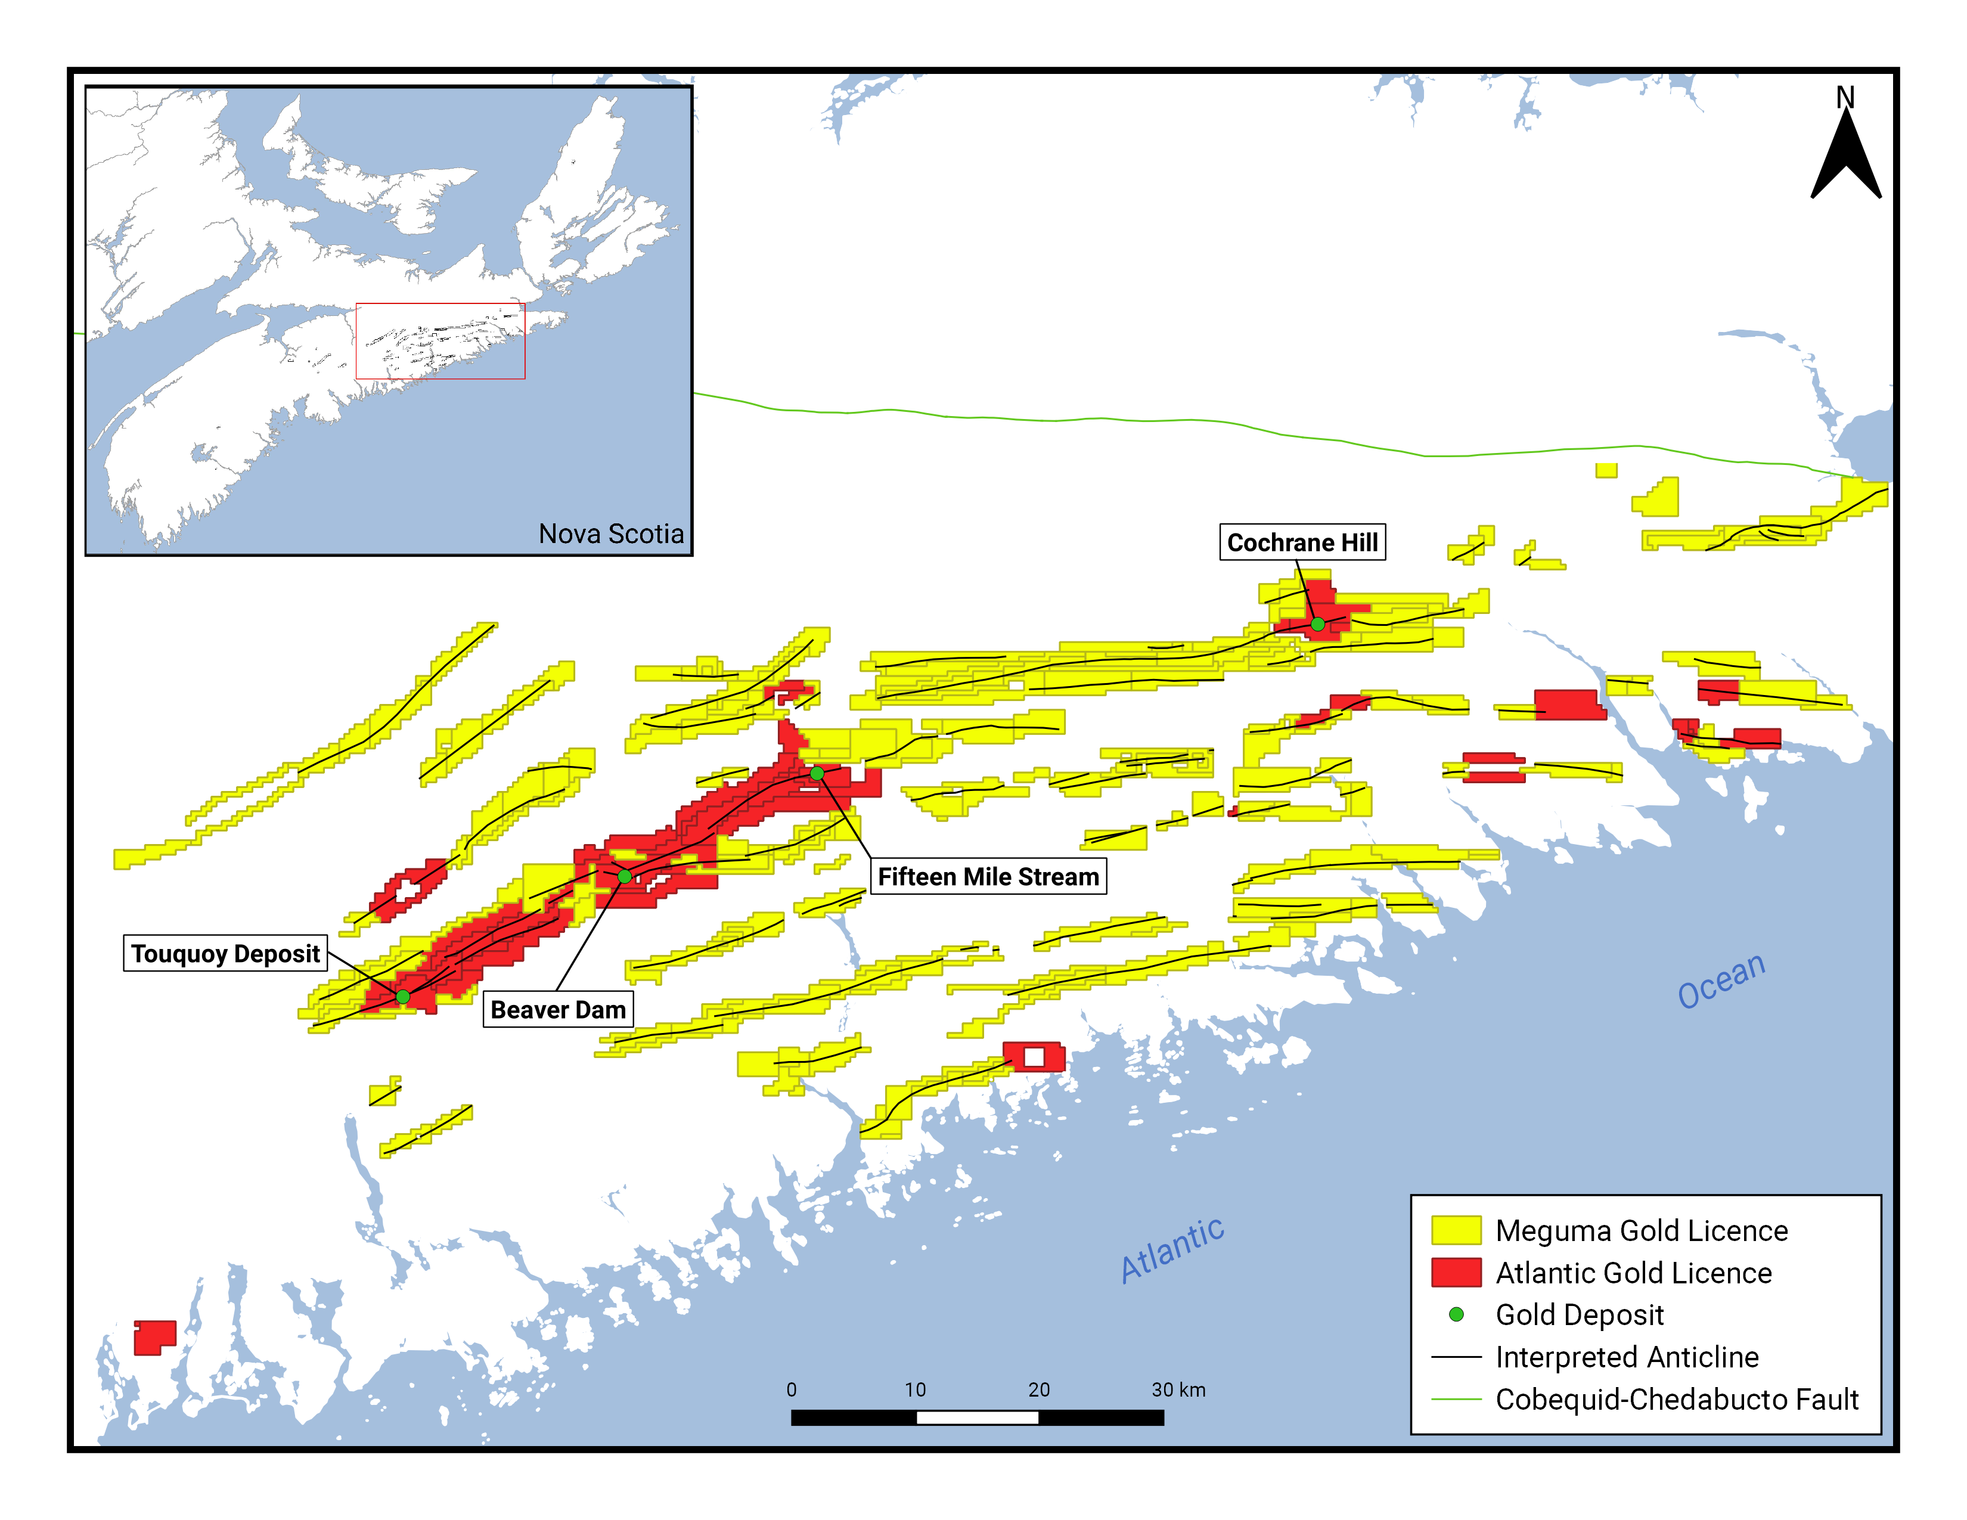
EXPLORATION AND DEVELOPMENT STRATEGY (CONTINUED)
Exploration work completed on the MegumaGold exploration licences in Eastern Nova Scotia include historical data compilation, a regional airborne magnetics/radiometrics survey, a regional LiDAR survey, a geological interpretation of the LiDAR dataset, geological modeling, prospecting, geological mapping and outcrop sampling, combined ground VLF and magnetics geophysical surveying, glacial till, and B-horizon soil geochemistry surveys, and a reverse circulation (RC) drilling program. These programs were carried out over an 18-month period starting in early 2018.

Till, Soil, and Rock sampling

A total of 1,482 rock samples were collected from the MegumaGold project areas, and 356 samples were analyzed for gold. Gold above the detection limit (>2.5 ppb Au) was recorded in outcrop or boulder samples at the Cochrane Hill area (23 ppb Au), Fifteen Mile Stream (6 ppb Au), Killag (12 ppb Au) and Dufferin property areas (3 ppb Au). Gold was also detected above the detection limit from samples taken from historic waste rock piles on the Killag property at the former historic mine site (up to 14.79 g/t).

A total of 189 till samples were collected during July and August of 2019 on the MegumaGold exploration licences. Gold values range from 5 to 19 ppb and are distributed throughout the different property areas. Arsenic values range from 5 to 75 ppm with a detection limit of 5 ppb. Gold anomalous samples from the Killag property areas are located along the trends of interpreted anticlinal structures. Gold results for a large B-horizon soil geochemistry survey carried out at the Touquoy West property ranging from 5 to 56 ppb with a detection limit of 5 ppb. Arsenic results returned for the same survey range from 2 to 900 ppm with a detection limit of 2 ppm. The soil geochemistry survey was successful at outlining three main arsenic-gold anomalies on the Touquoy West property. These anomalies parallel the interpreted northeast trend of the Moose River anticlinal fold corridor and are developed in areas either directly overlying, or to the south of, the interpreted main fold hinge zone.

Combined Ground Magnetometer/VLF-EM Surveys and Touquoy West IP Survey

The Company completed 25.83 line kilometres of Induced Polarization (IP) surveying in the Touquoy West project area in mid February 2020 based on the results of approximately 80 line km of high resolution ground magnetometer and VLF-EM surveying and a soil geochemistry program completed on the property in early 2019. The combined ground magnetometer and VLF-EM survey results were merged with compiled historical survey results from the adjacent St. Barbara Touquoy gold deposit property and the resulting dataset was independently processed to maximize definition of stratigraphic trends. These geophysical results were then used to interpret strike extensions of argillite-bearing stratigraphic intervals and anticlinal fold structures that host gold mineralization on the St. Barbara property onto the Touquoy West property, and to assist with selecting grid areas for the IP survey. The VLF-EM results define a conductivity trend coincident with the faulted axial zone of the main gold-focusing anticlinal fold in this gold district. This is interpreted to represent the presence of sheared argillite in the hinge zone of the anticline and can be traced southwest from the Touquoy gold mine area for at least 6 km to the western boundary of the Touquoy West survey grid, where it remains open along strike onto claims optioned in 2019 by MegumaGold from Genius Metals Inc.

Combined IP survey and geological compilation program results indicate that a well-developed chargeability anomaly coincides with the interpreted main anticlinal fold hinge zone trend on the Touquoy West property. This IP anomaly can be traced discontinuously for approximately 3.6 km across the Touquoy West survey grid and coincides with arsenic and gold soil geochemistry anomalies at several locations along its length. The anticlinal fold hinge zone trend currently remains open beyond the western grid limit onto MegumaGold exploration licences optioned from Genius. A second prominent chargeability anomaly occurs approximately 300 metres north of the main trend and has a strike length of approximately 700 metres. This chargeability anomaly also appears to coincide with anomalous 2019 soil arsenic and gold soil survey results and is associated with an interpreted argillite-bearing stratigraphic interval that may indicate a secondary anticlinal fold trend. A third chargeability anomaly west of the detailed survey block has been tentatively correlated between three survey lines along an 800-metre strike length. This third anomaly parallels the southern margin of a thick unit of interpreted argillite stratigraphy and is supported locally by anomalous arsenic and gold soil survey values. Resistivity anomalies occur peripherally to all three main chargeability anomaly trends and may mark zones of bedrock silicification associated with mineralization. The IP survey chargeability responses detected at Touquoy West, which are in part spatially associated with existing soil geochemistry, magnetometer, and VLF-EM anomalies, may indicate the presence of disseminated sulphide mineralization similar in style to that present adjacent to the Touquoy deposit located a few kilometres to the east along the Moose River Anticline.

EXPLORATION AND DEVELOPMENT STRATEGY (CONTINUED)

Exploration Model Developed

As a result of these efforts, the Company has developed a unique prospectivity model for identification of depositional gold environments within its district-scale land holdings. MegumaGold believes that this data analysis compilation and the resulting exploration model are significant achievements that will not only expedite and augment the ability to identify prime targets, but that will also greatly reduce the cost of producing results that have the potential to be converted to NI 43-101 standard resources. This program has yielded over 40 drilling targets for further investigation across the Company's prolific land package which are classified on priority based on the following characteristics:

1. High amplitude magnetic response;
2. Touqouy-like geochemical signature;
3. Gold bearing anticlinal structure;
4. Proximity to historically producing gold deposits; and
5. North west trending faults.

RC Drilling Program

A total of 20 holes totaling 1,614 metres were completed at the Killag East target area. These drill holes were designed to test gold mineralization in the area of historic Killag mine workings and along the high magnetic anomaly that coincides with the Killag anticline in this area. Drilling revealed that the bedrock sequences are predominantly comprised of greywacke interbedded locally with significant intervals of argillite. Quartz veining in both rock types is present and sulphide minerals such as pyrite, pyrrhotite, arsenopyrite and chalcopyrite were observed in RC chip samples. Pyrrhotite is the likely source of the high magnetic anomaly at Killag East. Above detection limit gold values were encountered in all holes and are associated with the interbedded greywacke and argillite intervals that were observed to have variable amounts of quartz veining. The highest gold value returned was 17,855 ppb (17.86 g/t) over 1 m and correlates with an interval of argillite.

A total of 9 holes totaling 633 metres were completed at the Killag Central and Killag West target areas within the Killag project area. Drilling in Killag West returned fire assay gold results mostly at or below the detection limit (1 ppb). The highest value returned was 7 ppb Au over 3 metres between 38 and 41 metres in drill hole KGRC-07-2019. Drill holes on the western part of the licence area mostly intercepted greywacke with 1 to 3 metre interbeds of argillite with associated sulphide mineralization consisting mostly of low levels of pyrite and arsenopyrite. RC drilling in the Killag Central area intersected a discrete high magnetic field anomaly that appears to be sourced in an argillite-rich interval of stratigraphy. At the southern end of the drill fence line, drill hole KGRC-17-2019 intercepted four zones of anomalous gold (>10 ppb) including 50 ppb over 1 metre between 16 to 17 metres; 40 ppb over six metres between 46 and 52 metres; 30 ppb over 5 metres between 58 and 63 metres; and 20 ppb over 1 metre between 72 and 73 metres. The geochemically anomalous zones are associated with extensive quartz veining in greywacke. The highest assay value returned in the four northernmost holes is 70 ppb Au between 45 and 46 metres in hole KGRC-16-2019.

The 2019 RC drilling at Killag referred to above intercepted high gold values in several quartz veined intervals of altered greywacke and argillite. Longer intervals of continuous, anomalous gold values in the 20 to 100 ppb range were intercepted in some of the 2019 holes and also have substantial exploration significance. These may denote presence of a gold-bearing hydrothermal alteration halo centered on the anticlinal corridor at Killag and form the basis of MegumaGold’s “alteration gold halo concept”. This concept is supported by alteration index and RC chip logging results. Where present, halo zone gold values typically fall in the range of 30 to 200 ppb and comprise continuously anomalous intervals up to 81 m in length.

Reverse circulation (RC) drilling programs were utilized by MegumaGold to target gold mineralization within or in close proximity to historic mining districts and to test for new gold mineralization along the high magnetic anomalies on strike with several interpreted anticlinal structures identified from 2018 aeromagnetic and radiometrics surveys. This drilling concept was successful at the Killag property where it revealed that significant intervals of sulphide bearing argillite occur interbedded with greywacke, both of which were locally determined to host abundant quartz veining. Sulphide minerals identified in drill chips include pyrite, pyrrhotite, arsenopyrite and chalcopyrite. Pyrrhotite associated with argillite stratigraphy is interpreted as the likely source of a high magnetic anomaly at Killag East that also coincides with areas of past gold mining. Notably, the east extension of the anticlinal structure present in the Killag Gold District hosts the Goldenville Gold District, approximately 50 km to the east.

EXPLORATION AND DEVELOPMENT STRATEGY (CONTINUED)

MegumaGold’s Killag RC drilling program intercepted near surface high gold values in several variably quartz-veined intervals of altered greywacke and argillite. This drilling also defined several long intervals of anomalous gold and associated anomalous arsenic values occurring in altered greywacke and argillite rock packages. These intervals occur along the axis of the Killag-Goldenville anticline and are located to the east of historical drill core gold intercepts and underground workings. The long widths of low level, but anomalous gold in Killag RC samples indicate that mineralization extends beyond the limits of traditionally known high grade quartz veins and that it has been deposited at low levels in surrounding thick slate/argillite/greywacke packages comprising the host rock sequence. This is interpreted as forming part of a hydrothermal alteration halo centered on the Killag anticline that may be part of a larger, zoned system that may contain significant gold grades. MegumaGold refers to this as its “alteration halo concept”. Alteration gold halos surrounding deposits of importance have already been documented in the Nova Scotia goldfields, examples of which include St. Barbara’s Touquoy, Fifteen Mile Stream, Beaver Dam and Cochrane Hill deposits, as well as Anaconda’s Goldboro deposit.

Determining potential exploration target areas over large geographic regions through the combined interpretation of airborne and ground geophysics data (magnetics, VLF-EM, and IP) and soil and rock geochemistry data has proven successful in discovering argillite-bearing anticlinal fold structures that contain disseminated iron sulphide and local gold mineralization within the MegumaGold properties. This exploration approach also appears useful in order to target high priority sites for future RC and diamond drilling programs. As discussed above, RC drilling in the Killag project area has demonstrated that alteration gold halo zones are present that require further follow-up drilling to assess this concept along the entire Killag anticline hinge zone corridor. The IP chargeability anomalies discovered at Touquoy West constitute high quality targets for pending diamond drilling programs to assess mineralization potential along this anticlinal trend and at depth. The combination of ground magnetics/VLF-EM and soil geochemistry surveys and follow-up IP surveys have also proven themselves as effective exploration tools in bedrock sequences of the Meguma Supergroup. The combined results define argillite-bearing stratigraphic intervals and anticlinal fold structures that may host significant gold mineralization associated with hydrothermally altered zones marked by disseminated sulphides and quartz veining.

KILLAG
The Killag Gold District is a historic Nova Scotia gold district held by MegumaGold and lies in the eastern part of Halifax County, approximately 13 km north of Sheet Harbour and 20 km east of Atlantic Gold’s Touquoy Gold Mine (Figure 1). Nova Scotia government records show that this district produced more than 3,500 ounces of gold between 1869 and 1946 at an average gold grade of 0.96 oz/ton. The geology in the area of historic mining is well known from earlier mapping, underground development and diamond drilling records. Much like the Touquoy Gold Mine area at Moose River, historic gold mining at Killag was primarily focused on quartz veins. At Killag these generally occur on the steeply south-dipping limb of the Killag-Goldenville anticline but some mining was carried out on the north limb of this fold as well. Records show that several separate veins were tested in the main area of underground workings. Of these, the Flat Lead, which is associated with a 1.21 m thick argillite belt and reportedly reaches 0.25 m in thickness, occurs on the north fold limb. The Stuart Lead is most prominent among historically worked veins and occurs on the near-vertical south limb of the anticline. It also is reported to reach 0.25 m in thickness. Quartz veining at Killag typically occurs in association with argillite rock packages of various thicknesses that are interbedded with thick greywacke units. Argillite intervals that did not host quartz veins were not typically sampled by pre-1980’s era exploration and mining projects.

EXPLORATION AND DEVELOPMENT STRATEGY (CONTINUED)
KILLAG (CONTINUED)
Figure 1: Map of MegumaGold holdings in the Killag area. 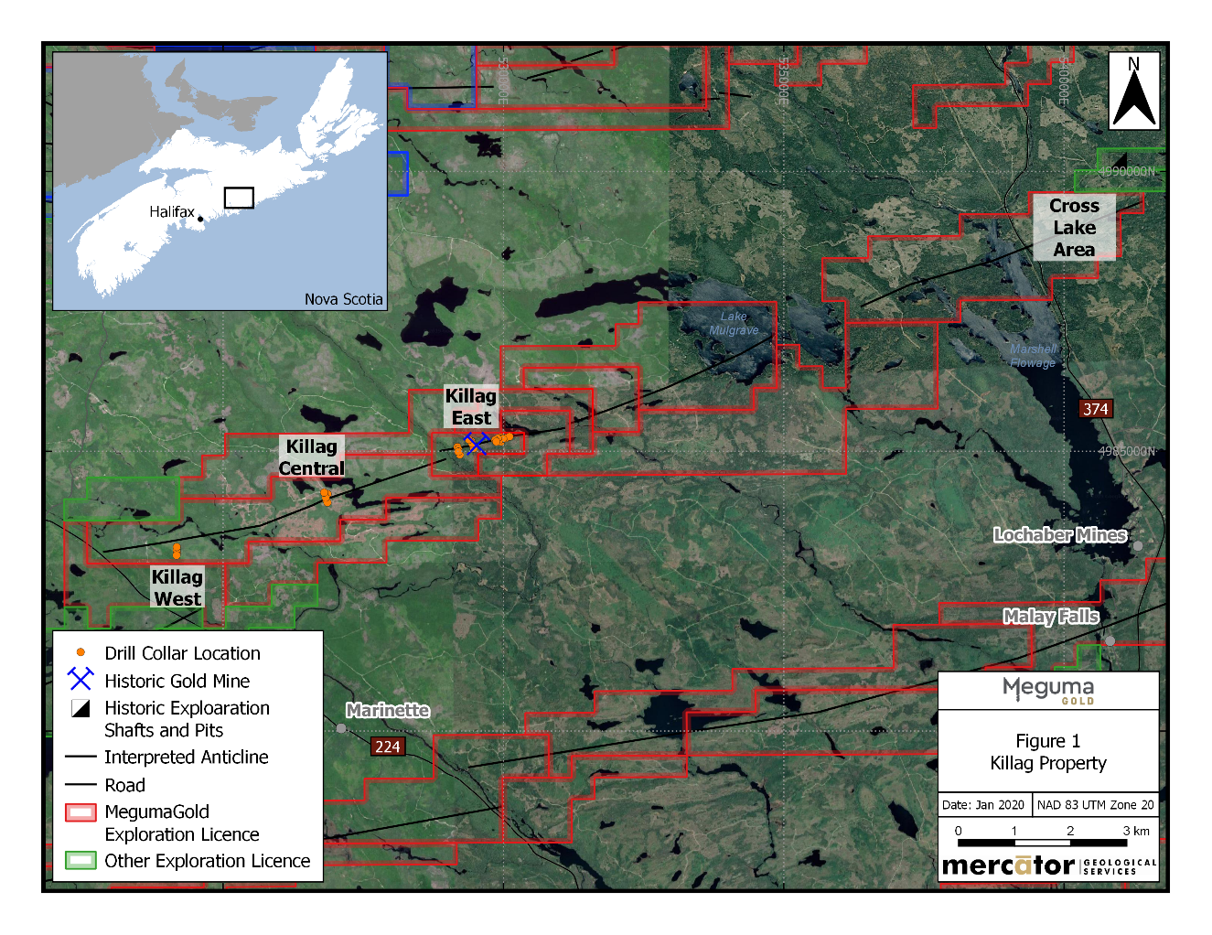
Interpretation of data compilation and 3D modelling programs carried out by MegumaGold in 2019 showed that historically defined higher grade gold mineralization at Killag occurs in association with quartz veined argillite packages that are folded across the Killag-Goldenville anticlinal hinge zone corridor. This corridor constitutes MegumaGold’s “Axis Zone” exploration target. The Axis Zone target is defined as an area of argillite thickening and increased gold-bearing vein frequency that occurs in the hinge zone of the fold. The zone also shows enhanced levels of hydrothermal alteration of the folded bedrock sequences. Similar styles of gold mineralization and alteration occur elsewhere in the Nova Scotia Goldfields, a prominent example being the Goldboro Deposit held by Anaconda Mining Corp. and the 149 Zone Deposit held by St Barbara Ltd. Frequency of quartz veining and the thickness of hosting argillite is typically greatest In the Axis Zone target area at Killag. (Figure 2)
2019 Reverse Circulation Drilling Program by MegumaGold
An initial Reverse Circulation (RC) drilling program by MegumaGold consisting of 28 holes (2,247 meters) was carried out at Killag in 2019 and identified gold mineralization associated with quartz veins and wallrock within a hydrothermally altered argillite and greywacke package along the hinge zone structural corridor of the Killag Anticline (Figure 2). While historic mining in the Killag Gold District between 1869 and 1946 had focused on discrete quartz veins, the recent RC drilling identified a broad envelope of pervasive, gold anomalism associated with altered bedrock sequence that hosts the quartz veins in the Axis Zone target area. This target area is currently of greatest interest to MegumaGold and is defined as an area of argillite thickening and increased vein density that occurs in the hinge zone structural corridor of the Killag Anticline.
EXPLORATION AND DEVELOPMENT STRATEGY (CONTINUED)
KILLAG (CONTINUED)
Figure 2: Drilling plan at Killag East.
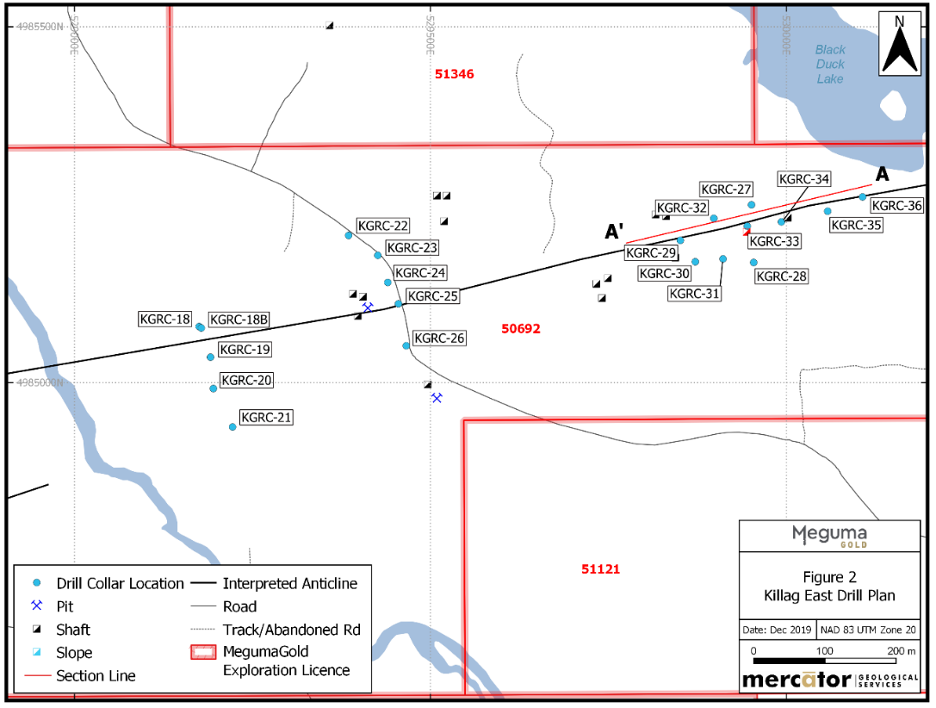
Results of the 2019 RC drilling program defined highly anomalous gold values over significant widths in several holes that intercepted bedrock sequences of interbedded quartz-veined greywacke and argillite (Table 1). A good example of this is a gold intercept grading 4.94 g/t over a continuously sampled length of 4 m, beginning at a downhole depth of 67 m in hole KGRC2019-32. The 2019 RC holes intercepted stratigraphy tested in part by earlier exploration as well as stratigraphy that was not directly tested by earlier work.
The 2019 RC program results in Table 1 define a corridor of gold anomalism that coincides with the hinge zone structural corridor (“Axis Zone”) target of the Killag-Goldenville anticline and measures at least 1 km in length. The anomalous trend is open to both east and west beyond the limits of the 2019 RC program and results of historic mining and core drilling within the area provide definition of the corridor’s generally gold-bearing character. Most RC holes include intervals of quartz-vein associated gold hosted by non-gold-bearing greywacke or argillite wallrock. However, several holes intercepted broad and coherent zones of low-level gold within hydrothermally altered greywacke and argillite within the interpreted anticlinal hinge zone structural corridor. The best example of this is found in Hole KRGC-36, which returned a weighted average gold grade of 0.12 g/t over a continuously sampled downhole length of 81 m, based on a nominal 20 parts per billion lower cut-off gold value. This and other weighted average intervals based on the same cut-off value appear in Table 2 and are represented in Figure 3 as the >20 ppb gold anomaly grey-shaded zone that is predominantly developed around holes KGRC-35 and KGRC-36. True thickness values for these intercepts are unknown at present.
EXPLORATION AND DEVELOPMENT STRATEGY (CONTINUED)
KILLAG (CONTINUED)
Table 1: 2019 RC Drilling Program - Highlights for Killag Property
Drillhole | Interval
KGRC-32 | 4 m at 4.94 g/t from 67m
KGRC-35 | 2 m at 2.74 g/t from 70
KGRC-31 | 4 m at 1.27g/t from 47 m
KGRC-35 | 2 m at 2.39 g/t from 55m
KGRC-30 | 2 m at 1.02 g/t from 95m
KGRC-36 | 4 m at 0.76 g/t from 49m
KGRC-35 | 2 m at 0.96 g/t from 77m
Note: True widths of the mineralized intervals are currently unknown
Table 2: 2019 RC Drilling Program – Weighted Average Low Level Gold Intervals
Hole | From (m) | To (m) | Length (m) | Weighted Average Gold Grade (g/t) | Max Au (g/t) | Min Au (g/t) | No. <.02 Au g/t
KGRC-31 | 55 | 65 | 10 | 0.14 | 0.57 | 0.01 | 1
KGRC-34 | 17 | 30 | 13 | 0.08 | 0.44 | 0.02 | 1
KGRC-35 | 8 | 50 | 42 | 0.06 | 1.12 | 0.01 | 5
KGRC-35 | 70 | 79 | 9 | 0.83 | 5.45 | 0.01 | 1
KGRC-36 | 8 | 89 | 81 | 0.12 | 2.46 | 0.01 | 5
Note: True widths of the mineralized intervals are currently unknown
Figure 3: A-A’ Longitudinal Section along Killag Anticline hinge in area of Killag historical mine workings.
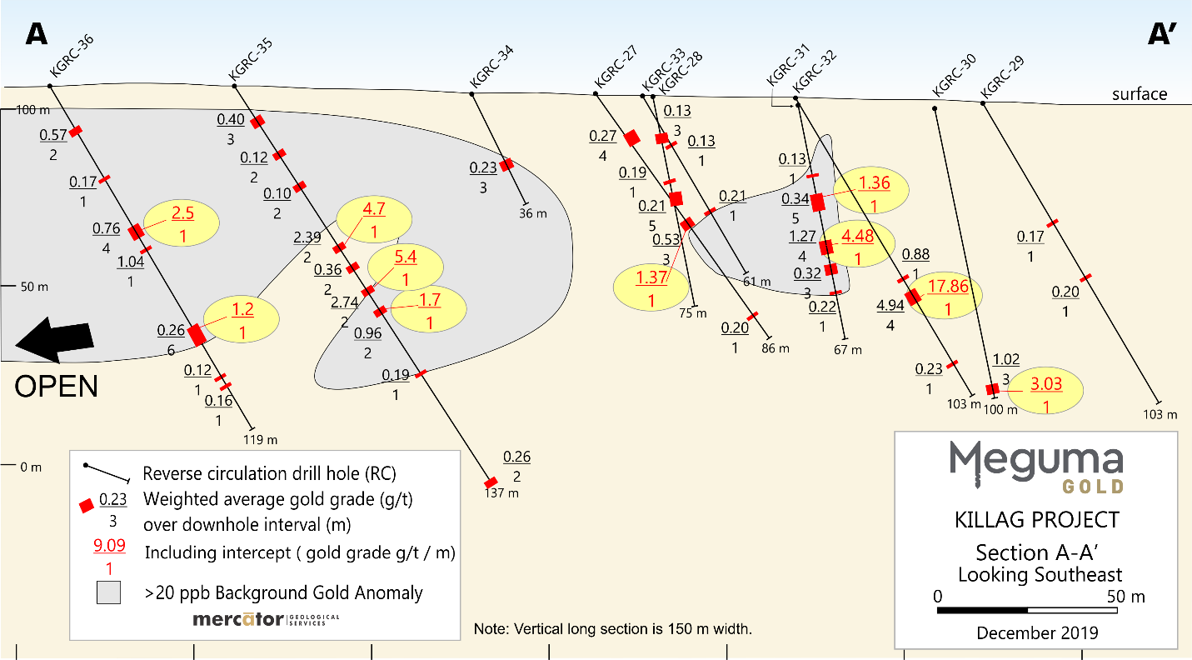
EXPLORATION AND DEVELOPMENT STRATEGY (CONTINUED)
KILLAG (CONTINUED)
The low level gold zones exemplified in results from holes KGRC-35 and KGRC-36 are interpreted by MegumaGold as forming part of a broad envelope of pervasive, gold anomalism associated with altered bedrock in the Killag anticline’s anticlinal hinge zone structural corridor, particularly east of the areas of past exploration drilling and underground investigations. Evidence of a similar low-level gold trend is also present in an interbedded greywacke and argillite section intercepted by MegumaGold’s RC hole KGRC-17 located approximately 1 km west of KGRC-36 along the same structural corridor. This distribution pattern is interpreted by MegumaGold as indicating that a significant, gold-bearing hydrothermal alteration system has affected the anticlinal hinge zone structural corridor on the Killag property. Importantly, the low-level gold halo zone coincides with anomalous lithogeochemical alteration index values calculated using MegumaGold’s proprietary methodology. Systematic testing of this mineralizing/alteration system’s affect, particularly in areas of argillite-rich stratigraphy along the anticlinal trend, is of highest exploration priority for MegumaGold.
To better understand the significance of the gold halo identified at Killag, the Company reviewed publicly available drilling results for several major gold deposits of the Nova Scotia Goldfields. This included data from the Touquoy Gold Mine and Beaverdam deposits held by St. Barbara Ltd. as well data from the Goldboro deposit held by Anaconda Mining Ltd. In each case a low level gold grade halo zone in the 10 to 100 parts per billion (ppb) range was identified in variably altered bedrock sequences that adjoin obviously gold-enriched areas that comprise significant mineralization of the respective deposits. Recognition of this association is important as it suggests that broadly developed low level gold anomalism in altered wallrock sequences is a potential indicator of proximity to a significant gold deposit. Review of datasets from several other areas that have less significant bedrock gold mineralization showed that pervasively developed low level gold halo mineralization is not developed in such settings.
Cross Lake Area – East Extension of Killag Property
MegumaGold completed a small till sampling program approximately 6 km east of the 2019 RC drilling program area, along the projected trend of the Killag-Goldenville anticlinal hinge zone corridor. In total, 11 samples were collected and submitted to Eastern Analytical (“Eastern”) in Springdale, NL for processing and analysis. Gold values between 6 parts per billion (ppb) and 11 ppb within fine-fraction C-horizon samples were returned and define a spatial grouping in one area that measures approximately 500 m in length by 200 m in width. MegumaGold feels that this group of anomalous gold values identifies a target area that warrants further systematic investigation. Historic work documented in Nova Scotia government databases for the area also returned locally anomalous till results. After completion of desktop compilation work and re-processing of historic ground geophysical data from this area, MegumaGold is planning to carry out prospecting, geological reconnaissance mapping, B horizon soil sampling and additional till sampling. Heavy mineral concentrates are also being prepared from the till samples already collected from the area and will be studied for gold and mineralogic content prior to geochemical analysis. Ground magnetometer and VLF-EM geophysical surveying will also be undertaken to augment compiled and reprocessed historic survey datasets. The goal for early 2020 work in this area of the property is to rapidly assess potential for definition of core drilling targets that could be tested later in 2020.

TOUQUOY WEST

The Touquoy property covers the southwest extension of the folded geological sequence that hosts the currently producing Touquoy Gold Mine operated by St. Barbara Ltd. (St Barbara) (Figure 4). The property covers a 4.3 km strike length of excellent exploration potential along the Touquoy Gold Mine structural corridor trend immediately southwest of, and adjoining, the St. Barbara holdings. In addition to covering the interpreted strike extension of this structural corridor’s airborne geophysical anomaly trend, the property covers approximately 5 km of strike length along St. Barbara’s southern claim boundary, south and west of the mine. The Touquoy Mine structural corridor forms part of the regionally developed Moose River-Beaverdam-Fifteen Mile Stream structural corridor that hosts St. Barbara’s Beaver Dam and Fifteen Mile Stream development projects in addition to its Touquoy Gold Mine (Figure 4).
EXPLORATION AND DEVELOPMENT STRATEGY (CONTINUED)

TOUQUOY WEST (CONTINUED)

Figure 4: MegumaGold’s Touquoy West Property holdings
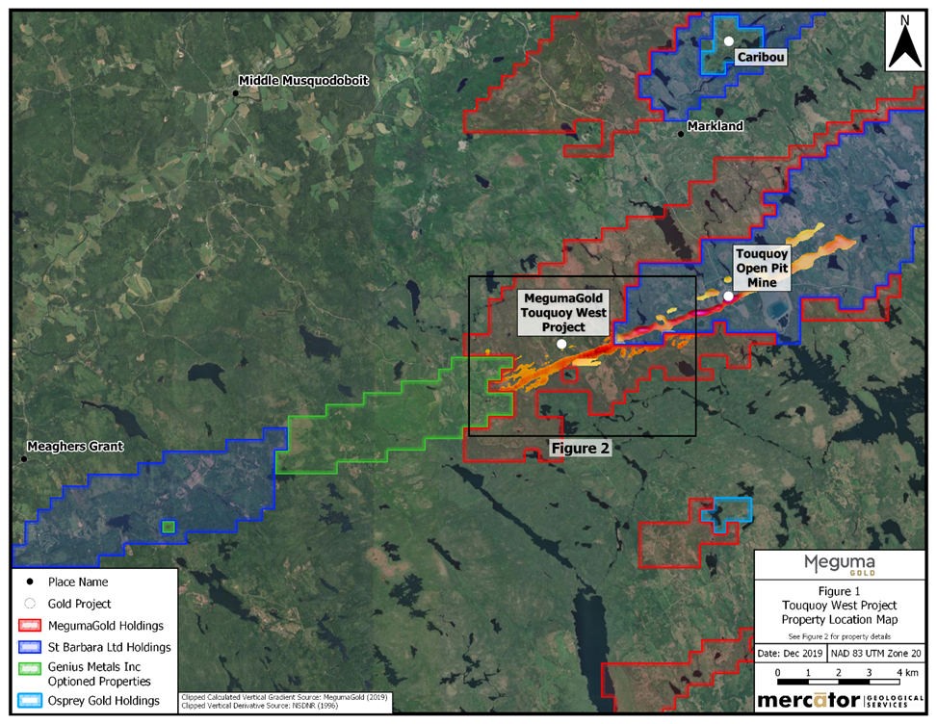

On December 4, 2019 MegumaGold entered into an option agreement with Genius Metals Inc. ("Genius"), to acquire up to a 100% interest in 6 mineral exploration licences totalling 100 claims (1,620 Hectares) that directly adjoins the Touquoy West property to the west. These cover the potential far-western extension of the favourable Moose River structural corridor trend. This acquisition substantially extends the Company’s land position across an area where publicly available Nova Scotia government records define several gold in till geochemical anomalies plus airborne magnetometer survey anomalies of exploration interest.

MegumaGold’s work to date on the Touquoy West property itself includes evaluation and compilation of all historic assessment work reporting plus completion of airborne and ground magnetometer surveys, a very low frequency electromagnetic (VLF-EM) ground survey, a limited till geochemistry survey, a large b-horizon soil geochemistry survey and 25.83 line kilometers of Induced Polarization (IP) surveying. Combined results of these programs define three high priority target areas on the Touquoy West property.

In 2018, MegumaGold flew an airborne magnetometer and radiometrics survey over the Touquoy West property to identify potential target areas for gold exploration. This data was merged with airborne magnetometer survey results published by the Nova Scotia Department of Natural Resources in 2006 to define the extent and character of Anomalies that extend from the Touquoy Gold Mine area continuously southwestward onto the Touquoy West property (Figure 4). MegumaGold interprets these as coinciding with the location of the highly favourable structural corridor and associated argillite-rich stratigraphy that includes the host sequence to the Touquoy Gold Mine deposit. The magnetic field anomaly trend is broadly coincident with VLF-EM anomalies defined through MegumaGold’s compilation studies of historic exploration results. The VLF-EM anomalies discontinuously parallel the axis of the main airborne magnetometer survey trend that extends southwest from the St. Barbara property onto the Touquoy West property. In combination with the airborne magnetic survey results, the VLF-EM features are interpreted as indicating potential for local presence of favourably folded and sheared argillite sequences that may be similar to those that host the Touquoy
EXPLORATION AND DEVELOPMENT STRATEGY(CONTINUED)

TOUQUOY WEST (CONTINUED)

Gold Mine.

The Touquoy West property has seen surprisingly little exploration to date. Notably, heavy mineral concentrates from six till samples collected on the property within 200 m of the St. Barbara boundary by Acadian Gold Ltd. returned visible gold grains (1 or 2 grains per sample – AR ME 2007-178). An earlier till geochemistry program carried out by Seabright Exploration Inc. (Seabright) in 1987 returned gold values in heavy mineral concentrate (HMC) samples from the property that range between the 2.5 parts per billion (ppb) gold detection limit and 3350 ppb (ME1994-021-1994). One multi-sample grouping of anomalous HMC results defines a target area measuring approximately 500 m in length by 250 m in width. This area remains open in all directions at present and no government records of detailed follow-up were found. The Company’s analysis of the airborne magnetometer survey datasets has also defined potential for presence of gold-mineralized secondary fold structures that parallel the main Touquoy Gold Mine structural corridor.

Historic core drilling by Seabright Exploration Inc. from a site on the Company’s claims in this area (Drill hole MR-87143: AR ME 88-178) encountered a thick, gold-anomalous sulphide-rich, argillite-bearing succession at a vertical depth of approximately 240 m below surface. This section is interpreted as being representative of the favourable stratigraphic sequence present along the Touquoy.

Figure 5: Results of the 2019 B-Horizon Soil Survey on MegumaGold’s Touquoy West Property

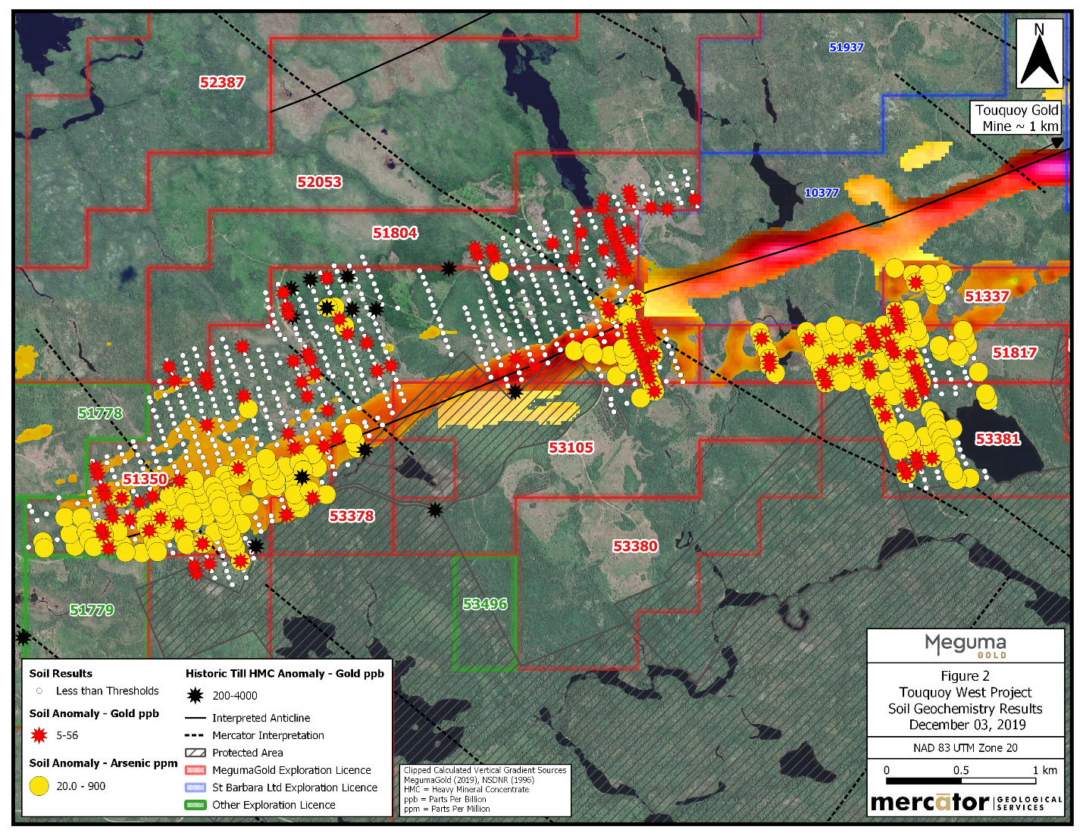

Gold Mine structural corridor on the adjacent St. Barbara property. Drill hole MR-87143 passes from MegumaGold claims onto St. Barbara holdings at depth, where the locally gold-anomalous sequence containing dark grey to black, sulphide-bearing argillite units interbedded with greywacke occurs over a cored interval of at least 180m, beginning at a downhole depth of approximately 320 m. This favourable unit is interpreted to dip southward, off of the St. Barbara
EXPLORATION AND DEVELOPMENT STRATEGY(CONTINUED)

TOUQUOY WEST (CONTINUED)

holding, and onto the Touquoy West property at depth, and to also extend continuously southwestward along-strike onto the Touquoy West property at nearer-surface elevations.

In October of 2019 MegumaGold launched an aggressive ground exploration program on the Touquoy West property. Initial work included completion of approximately 75 km of grid-based ground geophysical and B-Horizon soil geochemistry surveying. In addition, induced polarization (IP) surveying was initiated over the core airborne anomaly trend that extends onto the property from the adjacent St. Barbara holding.

The Touquoy West B-Horizon soil survey consists of 1062 soil samples collected during September and October of 2019 that were submitted for gold and multi-element analysis at Eastern Analytical Ltd. in Springdale, NL. Soil samples were collected along a grid measuring approximately 5.5 km in northeast extent, parallel to the underlying airborne magnetometer survey anomaly noted above, and from 0.1 to 1.5 km in northwest-southeast dimension, depending upon survey line location (Figure 5). The purpose of the soil geochemistry survey is to identify low level gold and arsenic anomalies present in soil that may be indicative of local bedrock gold mineralization along the favourable structural corridor that crosses the property.

Figure 5 summarizes the soil arsenic and gold analytical results for MegumaGold’s 2019 program. There are three areas of large-scale arsenic anomalism in soil geochemistry, all of which are locally supported by low-level, anomalous gold in soil values. The first soil arsenic anomaly (A) occurs in the western grid area and measures approximately 1.1 km in length and ranges between 100 m and 600 m in width. It is open onto the optioned Genius properties to the west. The second area of arsenic anomalism (B) occurs at the eastern limit of the Touquoy West claim group, where it adjoins St. Barbara holding. In that instance, anomalism occurs along a length of approximately 500 m and across a width range of 50 to 400 m. This trend remains open to the east, onto St. Barbara holding. The third soil arsenic anomaly (C) occurs in the eastern grid area directly south of St. Barbara holding and measures approximately 1.0 km in length and up to 1.0 km in width. The A and B arsenic and gold soil anomalies coincide in part with interpreted northwest fault corridors that disrupt the main structural corridor trend in the respective areas. This is significant, since a northwest cross-structure corridor and arsenic anomalism association are interpreted by the Company to mark bedrock sequences and derived soils in the vicinity of the Touquoy Gold Mine to the northeast.

Compiled results of historic till HMC gold surveying from Nova Scotia government sources are also presented in Figure 5. In comparison to soil samples, HMC samples typically have much higher anomalism thresholds due to their concentrated nature and this is represented in the Figure 5 legend by a gold threshold of 200 ppb. Soil gold values greater than 5 parts per billion (ppb) are also presented in Figure 4 and show coincident, but spatially irregular association with the A and B soil arsenic/gold anomalies mentioned earlier. Scattered anomalous gold values also form a spatial group in the north-central grid area where anomalous historic till (HMC) gold values (>200 ppb) have been reported.

In mid February 2020 MegumaGold completed a 25.83 line kilometres Induced Polarization (IP) survey on the Touquoy West survey grid, which was based on interpreted results of the ground magnetometer/VLF-EM surveying and B-horizon soil geochemistry programs completed on the property earlier in 2019.
The IP survey was carried out by Eastern Geophysics Ltd. of West Pubnico, Nova Scotia between January 13 and February 7, 2020 using a dipole-dipole survey array (a=25m or a=50m and N=6). IP survey data was processed using inversion methods to produce interpreted sectional and plan presentations of apparent resistivity and chargeability responses. Surveying at 100 m line spacing was carried out for 1.7 km westward from the St. Barbara Touquoy claim boundary and broadly spaced lines were surveyed further to the west over discrete anomalous soil geochemistry areas that generally coincide with VLF-EM east-west trending conductivity and magnetic field anomalies that are interpreted as marking the main anticlinal trend that extends west from the Touquoy deposit area and across the entire length of the Touquoy West property. Two lines of IP surveying were also completed south of the St. Barbara property boundary in an area marked by weaker geophysical survey results but anomalous B-horizon soil geochemistry Au and As results.

EXPLORATION AND DEVELOPMENT STRATEGY(CONTINUED)
TOUQUOY WEST (CONTINUED)

Combined IP survey and geological compilation program results indicate that a well-developed chargeability anomaly
coincides with the interpreted hinge zone trend of the Moose River Anticline on the Touquoy West property. This IP
anomaly can be traced discontinuously for approximately 3.6 km across the Touquoy West survey grid and coincides
with soil geochemistry anomalies at several locations along its length. The anticlinal fold hinge zone trend remains open beyond the western grid limit onto MegumaGold exploration licences optioned from Genius Metals Inc. in 2019.
A second prominent chargeability anomaly occurs approximately 300 m north of the main trend and has a strike length of approximately 700 m. This chargeability anomaly coincides in part with anomalous 2019 soil geochemistry results and is associated with an interpreted argillite-bearing stratigraphic interval that may indicate presence of a secondary anticlinal fold trend. A third chargeability anomaly west of the detailed survey block has been tentatively correlated between three survey lines along an 800 m strike length. This anomaly parallels the southern margin of a thick unit of interpreted argillite stratigraphy and is supported locally by anomalous gold and arsenic soil survey values. Several lesser chargeability targets have also been identified. Resistivity anomalies occur peripherally to all three main chargeability anomaly trends and may mark zones of bedrock silicification associated with mineralization.

The IP survey chargeability responses detected at Touquoy West, which are in part spatially associated with existing soil geochemistry, magnetometer, and VLF-EM anomalies, may indicate the presence of disseminated sulphide mineralization similar in style to that present adjacent to the Touquoy gold deposit located a few kilometres to the east along the Moose River Anticline trend. These IP anomalies therefore constitute high-quality targets for future diamond drilling programs on the property to assess the potential for gold mineralization along the trend and at depth, with the main anticlinal trend anomaly being highest in priority, followed by the two anomalous trends further north on the grid that are parallel to the main trend.

MegumaGold considers further evaluation of the three main Touquoy West anomalies to be a priority for the Company. To that end, the Company is currently designing a maiden detailed diamond drilling program to these targets for near surface mineralization and at depth. Evaluation of the newly acquired Genius property to the west is also a priority and is expected to begin with completion of a high resolution airborne magnetometer and radiometrics survey followed by a till geochemistry, geological mapping, prospecting, and, ultimately, ground geophysics and soil sampling surveys during the 2020 field season, results of which are anticipated to define core drilling targets.

Cariboo Gold Properties
In fiscal 2019, the Company completed the acquisition of 116 and will enter the historic Cariboo Gold District, which will comprise of the following projects:
- The Cariboo Gold Project comprises multiple tenure blocks totaling 4,515 hectares, which strategically target the Transitional or Basalt Siltstone of the Barkerville Terrain.
- The Lac La Hache Gold Project represents exposure to a new, emerging gold exploration area of the Cariboo Gold District, located northeast of 100 Mile House. The project comprises approximately 180 hectares of exploration ground situated on the north shore of Spout Lake, in close proximity to the recent discovery on the south shore of the lake by Engold Mines Ltd.
- The Pinto Gold Project is a gold exploration target located in southern British Columbia and is approximately 80.9 hectares in size.
In conjunction with the above, the Company acquired 100% of the common shares of a privately-held company that owns the Cariboo Gold, Lac la Hache and Pinto gold projects from arm’s-length vendors and issued 17.5M common shares of the Company and made a cash payment of $25,000. No finders’ fees were paid on the transaction.

EXPLORATION AND DEVELOPMENT STRATEGY(CONTINUED)

Outlook
Follow-up drilling of high probability targets at the Killag and Touquoy West Properties will commence once the permitting process has been completed to the satisfaction of the Nova Scotia Department of Energy and Mines. Management is of the opinion that the initial 2019 RC drilling results at Killag confirm the Axial Zone as an important new exploration target on the property that remains open for assessment both along strike and down dip along the entire 6 km length of the Killag anticline. Similar potential is also recognized along the further east and west strike extensions of the anticline that define the entire Gold Lake-Killag-Goldenville structural corridor. The Goldenville deposit, located roughly 35 km east of Killag along this corridor is detailed in Nova Scotia government records and has historic gold production of more than 200,000 oz from the district at an estimated average gold grade of approximately 12g/t. MegumaGold believes that this production history is indicative gold endowment of this structural corridor, along which the company holds the largest current exploration land position.
Properties identified through field work for immediate follow up programs to run concurrently with upcoming Killag and Touquoy drilling include:
- Como Lake
- Kent Lake
- Gold Lake
Como Lake Target
The Como Lake target area is located between Tait Lake and the west shore of Como Lake, in Halifax County, NS. The licence area is approximately a 30‐minute drive from Sheet Harbour on the eastern shore of Nova Scotia and can be easily accessed via highway 224 and then by the Beaver Dam access road and associated forestry roads. Licence 51645 consists of 11 claims covering 178 hectares and is in good standing until June 28, 2021. The licence area is approximately 600 m north of the interpreted faulted extension of the Beaver Dam‐Fifteen Mile Stream Anticline and the Beaver Dam gold deposit held by Atlantic Gold Corporation (Atlantic) is located approximately 2 km south of the licence. The nearest known NS Mineral Occurrence (E02‐022‐Como Lake) is located 500 metres south of the licence and consists of native gold found in a quartz boulder (float) that is noted on an early Geological Survey of Canada (GSC) map of the area (Faribault, 1897). MegumaGold collected 28 rock samples from the Licence area during the 2018 field season and these were analyzed by XRF to allow application of the company’s Touquoy Lithogeochemical Factor. Lithogeochemical Factor results were also calculated for multielement data available for earlier rotary percussion or RC drilling programs completed in and around the area by others. Analysis of data from the field program results define an anomaly in two outcrop samples within which both samples have low (positive) Touquoy Lithogeochemistry Factor scores. Analysis by the company in 2018 of associated DDV drill chip multi‐element data shows that five of the interface RC holes within Como lake Licence are also characterized by low (positive) scores. The results of the Touquoy Lithogeochemical Factor work indicate a local presence of alteration similar to that present in the alteration halo of the Touquoy gold deposit.
The Como Lake target area is well positioned in proximity to Atlantic Gold’s “Corridor” regional exploration program holdings and occurs on the north side of that company’s regionally recognized Moose River Formation. Coincident aeromagnetic survey trends in this area follow argillite‐rich stratigraphy, track airborne and ground survey defined VLF‐EM conductors, and locally coincide with interpreted anticlinal closure zones mapped in this area. A weak, historic gold in soil anomaly also coincides with the area. The soil anomaly in the lower east corner of the Licence is broadly coincident with a slightly anomalous Touquoy Lithgeochemical Factor value site. In combination, these factors make the Licence area at Como Lake a good quality target for further exploration. To further assess this target area, the company is preparing at minimum three VLF‐EM ground survey lines initially be completed along north‐south traverses across the property to ground‐locate conductive zones detected by the earlier airborne and ground VLF‐EM surveys. Line spacing is between 400 and 500 m and line lengths are approximately 1 km. Results of the ground VLF‐EM survey should aid in outlining underlying fold structures and assist in focusing future RC drilling traverses.
EXPLORATION AND DEVELOPMENT STRATEGY(CONTINUED)

Kent Lake Target

The Kent Lake target area centered in the Rocky Brook Lake and Kent Lake area of Halifax County, NS. The licence area is approximately a 30 minute drive from Sheet Harbour on the eastern shore of Nova Scotia and can be easily accessed via highway 224 and then by a forestry road network that trends north and east from highway 224 in the Beaver Dam area. The Licence consists of 71 claims covering 1,149 hectares. The licence area is approximately 5.5 km west of the Beaver Dam gold deposit. The company collected 65 rock samples from the Licence area during the 2018 field season and these were analyzed by XRF to allow application of MegumaGold’s Touquoy Lithogeochemical Factor. Lithogeochemical Factor results were also calculated for multielement data available for earlier rotary percussion or RC drilling programs completed in and around the area by others. Analysis of data from the field program results define an anomaly in eight outcrop samples within which seven samples have low (positive) Touquoy alteration geochemical scores and one had a high (positive) score. Analysis by the company in 2018 of associated DDV drill chip multi‐element data shows that eight of the interface holes within the Licence are also characterized by low (positive) Touquoy Lithogeochemical Factor scores. Grouping of results occurs along the central and northern airborne magnetic survey trends that cross the property and these are candidates for possible Beaver Dam deposit host stratigraphy extensions. The combined factor scores indicate at least local presence of alteration similar to that seen in the outer alteration halo of the Touquoy gold deposit. Factor scores are significantly lower than those that characterize the main mineralized zone at the Touquoy deposit.

The Kent Lake target area is well positioned within Atlantic Gold’s “Corridor” regional program area and on the north side of the limits of the favourable, argillite‐dominated Moose River Formation and Fifteen Mile Stream Formation. Coincident aeromagnetic high trends, airborne VLF‐EM conductors and the interpreted Moose River‐ Beaver Dam‐Fifteen Mile Stream anticlinal trend all cross Meguma Gold’s Licence and enhance its exploration potential.

The company plans to acquire new VLF‐EM ground survey data along north south survey lines that cross the property. Line spacing ranges from 250 to 1,000 m and line lengths range from approximately 750 to 2,000 m. Results of the ground VLF‐EM survey will aid in outlining the trends of fold structures that are interpreted to be present on the property and thereby contribute to positioning of the proposed subsequent RC drilling traverses.
Gold Lake Target
The Gold Lake target area Mineral Exploration Licences are located in central Nova Scotia, approximately 20 km south of the community of Middle Musquodoboit and 60 km northeast of the city of Halifax. It is most readily accessed via the Murchyville forestry road network that extends from that community, approximately 7 km south of Middle Musquodoboit, to the community of Mooseland, approximately 40 km to the east. The main forestry road crosses the claim group and various secondary roads and trails provide access to the extents of the property. The area can also be accessed from Tangier, on the eastern shore of Nova Scotia, by traveling north on Mooseland Road approximately 20 km to the community of Mooseland and then west 17 km along the main forestry road to the Gold Lake area. The property is situated on the Gold Lake‐Killag‐Goldenville anticline that trends north-easterly in this area. Historical gold mining and exploration have been focused on the east side of Gold Lake, on an adjacent mineral exploration property. Historic ground magnetometer, induced polarization (IP) and VLF‐EM survey data are available for the east and west sides of Gold Lake. One VLF‐EM conductor defined by historic ground surveys is coincident with both the anticlinal hinge zone at Gold Lake and the previously explored “Iron Lead” on the east side of the lake. The conductor trend extends from the east side of the lake to the substantially less‐explored west side that is covered by the MegumaGold licence. Notably, the VLF‐EM conductor is coincident with a small, untested magnetometer survey high on the licence, that is located approximately 1 km west of the lake. The Company carried out a limited program of outcrop sampling on the company’s claims west of Gold Lake during the 2018 field season and samples were submitted for in‐house XRF analysis. XRF results produced low to moderate Touquoy Lithogeochemical Factor scores for these samples. The main exploration opportunity presented by the Gold Lake property is for discovery of well-developed gold mineralization in the hinge zone of the main anticline that crosses the property. In the best case, this would take the form of gold‐bearing quartz saddle veins, leg veins and bedding parallel veins that occur in association with structurally thickened, altered and gold mineralized argillite units in the core of the anticline.
EXPLORATION AND DEVELOPMENT STRATEGY(CONTINUED)

Gold Lake Target (Continued)
This style of composite mineralization can be considered similar to some mineralized settings defined to date at Anaconda Mining’s Goldboro deposit to the east and, possibly, in some parts of St Barbara’s Fifteen Mile Stream deposit to the northeast.

The Company’s planned exploration approach is to complete several ground VLF‐EM survey transects across the trends of previously defined ground VLF‐EM survey conductors to confirm their locations. These conductors are interpreted as being generally coincident with the axial zone of the main anticlinal trend in this district, which is also the zone of highest perceived exploration potential. After completion of the ground VLF‐EM lines, the company is planning a reconnaissance line of reverse circulation (RC) drill holes be completed across the trace of the defined VLF‐EM conductors and the coincident, high resolution airborne magnetometer survey anomaly. The latter was defined by the company’s airborne survey of the property completed in 2018. The geological, geophysical and lithogeochemistry results at Gold Lake are interpreted as indicating the presence of a gold‐bearing alteration system on the property that may be associated with undiscovered gold mineralization.

Qualified Person
Mr. Fred Tejada, a Qualified Person within the meaning of National Instrument 43-101, and a director of the Company, has reviewed the technical information in this MD&A.
CONSOLIDATED RESULTS OF OPERATIONS
All of the balances set out in this and following sections, including the Summary of quarterly results conform to IFRS standards.
 |  |  | June 30,  2020 | June 30,  2019
 |  |  | $ | $
Professional fees |  |  | 24,700 | 16,601
General and administrative |  |  | 5,325 | 57,653
Regulatory, transfer agent and filing fees |  |  | 6,715 | 48,064
Corporate development |  |  | 48,936 | -
Management, consulting and director’s fees |  |  | 127,294 | 87,059
Foreign exchange loss (gain) |  |  | (4,775) | (1,552)
Interest income |  |  | 664 | (3,250)
 |  |  | 208,859 | 204,575
OTHER ITEMS
Flow-through liability reversal |  |  | (31,201) | (439,118)
Realized gain on sale of marketable securities |  |  | (49,478) | -
Unrealized gain on marketable securities |  |  | (48,690) | -
Net income (loss) and comprehensive income (loss) for the period |  |  | (79,490) | 234,543

For the three months period ended June 30, 2020 and 2019

The Company recorded a net loss of $79,490 for the period ended June 30h 31, 2020 compared to a net income of $234,543 for the corresponding period in 2019. Some of the significant charges to operations are as follows:
- Corporate development fees of $48,936 (2019 - $Nil), include brand awareness and marketing activities to spread awareness of the Company’s exploration activities in Nova Scotia with concentrated activities in North America and Europe.
- Professional fees of $24,700 (2019 - $16,601) include legal, audit and accounting services. The increase is attributed to legal fees associated with the plan of arrangement with Osprey Gold Development Ltd that closed subsequent to period end.
- General and administrative expense of $5,325 (2019 - $57,653), which reflected a decrease attributable to travel, promotional and office expenditures related to the exploration and evaluation activities during the period ended June 30, 2020. In addition, due to the impact of Covid-19 on the last quarter for fiscal 2020, Company operations and expenditures were slowed.
- Management and consulting fees of $127,294 (2019 - $87,059) relate to general consulting and managements fees. The Company relies heavily on Consultants to help them achieve their goals on all facets of business. Consultants include Management, Advisors, Technical Support and other support roles. The increase during the period ended June 30, 2020 mainly relates to marketing efforts amid Covid-19 pandemic.
- The Company recorded interest expense income of $664 (2019 – income $3,250). The 2019 income relates to the interest earned on the Company’s GIC which is redeemed during the period ended June 30, 2020.
- The Company recorded a reversal of flow through liability of $31,201 (2019 - $439,118), which reflects the exploration and evaluation expenditures incurred during the period.
- The Company recorded unrealized gain on marketable securities of $48,690 as the company held Osprey shares during the period ended June 30, 2020.
- The Company recorded gain on sale of marketable securities from the sale of the 3,177,000 Osprey common shares for gross proceeds of $192,443 during the period ended June 30, 2020.

CONSOLIDATED RESULTS OF OPERATIONS (CONTINUED)

SUMMARY OF QUARTERLY RESULTS
The table below presents selected financial data for the Company’s eight most recently completed quarters, all prepared in accordance with IFRS.

 | June 30 | Mar 31 | Dec 31 | Sep 30, | Jun 30, | Mar 31, | Dec 31 | Sep 30
 | 2020 | 2020 | 2019 | 2019 | 2019 | 2019 | 2018 | 2018
 | $ | $ | $ | $ | $ | $ | $ | $
Net income (loss) | (79,490) | (479,920) | (648,397) | (411,485) | 234,543 | 24,950 | (54,021) | (172,282)
loss per share | (0.00) | (0.00) | (0.01) | 0.00 | 0.00 | (0.01) | (0.00) | (0.00)
Balance Sheet
Total Assets | 15,781,510 | 15,842,960 | 14,979,346 | 15,511,674 | 16,002,982 | 16,665,547 | 16,631,330 | 16,373,023
Fluctuations in Assets are mostly due to cash on financing activities and deployed to property investigation and acquisition and advancement of exploration and evaluation assets. The amount and timing of expenses and availability of capital resources vary substantially from quarter to quarter, depending on the level of exploration activities being undertaken at any time and the availability of funding from investors or collaboration partners.
LIQUIDITY AND CAPITAL RESOURCES
The financial statements have been prepared on a going-concern basis, which assumes the realization of assets and liquidation of liabilities in the normal course of business. Continuing operations, as intended, are dependent on management’s ability to raise required funding through future equity issuances, its ability to acquire resource property or business interests and develop profitable operations or a combination thereof, which is not assured, given today’s volatile and uncertain financial markets. The Company may revise exploration and development programs depending on its working capital position.

As at June 30, 2020, the Company had a working capital of $345,128 (March 31, 2020 – $495,107) which primarily consisted of cash of $919,947 (March 31, 2020 - $1,023,103), receivables of $18,946 (March 31, 2020 - $49,882) and prepaid expenses of $Nil (March 31, 2020 - $7,521). Current liabilities, being accounts payable and accrued liabilities as at June 30, 2020 amounted to $634,021 (March 31, 2020 - $613,730) and flow through liability of $229,504 (March 31, 2020 - $260,705). Refer to the Financial Statements for more information on the use of cash in operating, investing and financing activities for the period ended June 30, 2020.

Other than the above-mentioned current liabilities, the Company has no short-term capital spending requirements and future plans and expectations are based on the assumption that the Company will realize its assets and discharge its liabilities in the normal course of business rather than through a process of forced liquidation. There can be no assurance that the Company will be able to obtain adequate financing in the future or if available that such financing will be on acceptable terms. If adequate financing is not available when required, the Company may be required to delay, scale back or eliminate various programs and may be unable to continue in operation. The Company may seek such additional financing through debt or equity offerings. Any equity offering will result in dilution to the ownership interests of the Company’s shareholders and may result in dilution to the value of such interests.

LIQUIDITY AND CAPITAL RESOURCES (CONTINUED)
The Company’s future revenues, if any, are expected to be from the mining and sale of mineral products or interests related there to. The economics of developing and producing mineral products are affected by many factors including the cost of operations, variations in the grade of ore mined, and the price of metals. Depending on the price of metals, the Company may determine that it is impractical to continue commercial production. The price of metals has fluctuated widely in recent years and is affected by many factors beyond the Company’s control including changes in international investment patterns and monetary systems, economic growth rates, political developments, the extent of sales or accumulation of reserves by governments and shifts in private supplies of and demands for metals. The supply of metals consists of a combination of mine production, recycled material, and existing stocks held by governments, producers, financial institutions and consumers. If the market price for metals falls below the Company’s full production costs and remains at such levels for any sustained period of time, the Company will experience losses and may decide to discontinue operations or development of other projects or mining at one or more of its properties at that time.

LIQUIDITY AND CAPITAL RESOURCES – CASH FLOW

Operating Activities:

Cash used in operating activities for the period ended June 30, 2020 was $233,445 as compared to $694,794 in the comparative period. Fluctuations in operating activities is attributed to a funds received in advance for a private placement, resulting in a cash inflow in operating activities.

Investing activities:
Cash used in investing activities for the period ended June 30, 2020 was $182,337 as compared to $317,268 in the prior period. During the period ended June 30, 2020, the Company continued to explore the Meguma project and incurred exploration and evaluation costs of $10,106 (2019 - $317,268) and sold key investments for $192,443 and realized an overall gain of $49,478.

FInancing activities:

Cash used in financing activities for the period ended June 30, 2020 was $50,050 as compared to $Nil in the prior period which saw issuance of large amount of common shares.

TRANSACTIONS WITH RELATED PARTIES

The Directors and Executive Officers of the Company are as follows:

Theo van der Linde Director and President
Regan Isenor Chief Executive Officer
Peter Nguyen Chief Financial Officer
Stephen Stine Director
Fred Tejada Director

The Company incurred the following related party transactions, with associated persons or corporations, which were undertaken in the normal course of operations and were measured at the exchange amount as follows:
TRANSACTIONS WITH RELATED PARTIES (CONTINUED)

- Key management includes directors, executive officers and officers which constitutes the management team. The Company paid or accrued compensation in form of consulting fees to companies controlled by directors, executive officers and officers and share based compensation directly to directors, executive officers and officers as follows:

For the three months period ended | June 30,  2020  $ | June 30,  2019  $
Consulting fees accrued or paid to a company controlled by the President | 18,000 | 18,000
Consulting fees accrued or paid to a company controlled by the CFO | 15,000 | 15,000
Consulting fees accrued or paid to a company controlled by the CEO | 39,360 | 39,975
 | 72,360 | 72,975

- As at June 30, 2020, total amounts payable to directors and companies owned by directors in accounts payable and accrued liabilities were $258,115 (March 31, 2020 - $270,064).

Financial instruments and risks

The Company’s financial instruments consist of cash and cash equivalents, receivables, loans payable, contingent consideration and accounts payable and accrued liabilities. The fair value of these financial instruments approximates their carrying values, unless otherwise noted.

The Company’s risk exposures and the impact on the Company’s financial instruments are summarized below:

Credit risk

Credit risk arises from the non-performance by counterparties of contractual financial obligations. The Company’s exposure to credit risk includes cash and other receivable. The Company reduces its credit risk by maintaining its bank accounts at large international financial institutions. Other receivable represents GST/HST due from the Canadian government. The maximum exposure to credit risk is equal to the fair value or carrying value of the financial assets. The Company has assessed credit risk as low.

Liquidity risk

Liquidity risk is the risk that the Company will not have sufficient liquidity to meet its financial obligations as they come due. The Company has a planning and budgeting process in place to help determine the funds required to support the Company’s normal operating requirements on an ongoing basis. The Company cautions that there are no cash flows from operations. The Company feels that its current cash holdings is adequate to meet its anticipated short-term obligations.

Historically, the Company's sole source of funding has been the issuance of equity securities for cash, primarily through private placements. The Company’s access to financing is always uncertain. There can be no assurance of continued access to significant equity funding. As at June 30, 2020, the Company had a cash balance of $919,947 (March 31, 2020 - $1,023,103) to settle current liabilities of $863,525 (March 31, 2020 - $874,435).

Financial instruments and risks (CONTINUED)

Market risk

Market risk is the risk of loss that may arise from changes in market factors such as interest rates, foreign currency and price risk.
- Interest rate risk
Interest rate risk is the risk that the fair value of future cash flows of a financial instrument will fluctuate because of changes in the market interest rates. The Company has no material exposure at June 30, 2020 to interest rate risk through its financial instruments.
- Foreign currency risk
Foreign currency risk is the risk that the fair values of future cash flows of a financial instrument will fluctuate because they are denominated in currencies that differ from the respective functional currency. During the year ended March 31, 2020, the Company sold its subsidiary in the United States and the Company does not have any financial instruments denominated in a foreign currency as at June 30, 2020. Foreign currency risk is assessed as low.

- Price risk

The Company’s exposure to price risk with respect to commodity and equity prices is minimal due to the fact that the Company is still in the exploration stage with no earnings. Equity price risk is defined as the potential adverse impact on the Company’s earnings due to movements in individual equity prices or general movements in the level of the stock market. Commodity price risk is defined as the potential adverse impact on earnings and economic value due to commodity price movements and volatilities. The Company intends to closely monitor commodity prices of gold and other precious and base metals, individual equity movements, and the stock market to determine the appropriate course of action to be taken by the Company when warranted.

Other InformatioN

Off Balance Sheet Items

The Company has no off-balance sheet arrangements.

Going Concern

These consolidated financial statements have been prepared on a going-concern basis, which assumes the realization of assets and liquidation of liabilities in the normal course of business. Several material uncertainties lend significant doubt on the validity of this assumption. The Company has incurred losses since inception and has no current source of revenue. Continuing operations, as intended, are dependent on management’s ability to raise required funding through future equity issuances, its ability to acquire resource property or business interests and develop profitable operations or a combination thereof, which is not assured given the volatile and uncertain financial markets. These consolidated financial statements do not include any adjustments to the recoverability and classification of recorded asset amounts and classification of liabilities that might be necessary should the Company be unable to continue as a going concern. At June 30, 2020, the Company had a deficit of $23,560,081 (2019 - $23,480,591) and working capital of $345,128 (2019 – 495,106). There can be no assurance that the Company will be able to continue to raise funds, in which case the Company may be unable to meet its obligations. Should the Company be unable to continue as a going concern, the net realizable values of its assets may be materially less than the amounts recorded on the condensed interim consolidated statements of financial position.
There can be no assurance that the Company will be able to continue to raise funds, in which case the Company may be unable to meet its obligations. Should the Company be unable to continue as a going-concern, the net realizable values of its assets may be materially less than the amounts recorded on the consolidated statement of financial position.
Management of capital
The Company’s objectives when managing capital are to safeguard the Company’s ability to continue as a going concern in order to pursue suitable business opportunities and to maintain a flexible capital structure for its projects for the benefit of its stakeholders. As the Company is in the exploration stage and has not achieved commercial operations from its projects, its principal source of funds is from the issuance of common shares.
In the management of capital, the Company includes the components of shareholders’ equity (deficiency). The Company manages the capital structure and makes adjustments to it in light of changes in economic conditions and the risk characteristics of the underlying assets. To maintain or adjust the capital structure, the Company may attempt to issue new shares, enter into joint venture property arrangements, acquire or dispose of assets or adjust the amount of cash and cash equivalents and investments.
In order to facilitate the management of its capital requirements, the Company prepares monthly and annual expenditure budgets that are updated as necessary depending on various factors, including successful capital deployment and general industry conditions. The annual and updated budgets are approved by the Board of Directors. The Company’s investment policy is to invest its cash in highly liquid short-term interest-bearing investments with maturities of three months or less from the original date of acquisition, selected with regards to the expected timing of expenditures from continuing operations. The Company is uncertain as to whether its current capital resources will be sufficient to carry its exploration and development plans and operations through its current operating period and, accordingly, management is reviewing the timing and scope of current exploration plans and is also pursuing other financing alternatives to fund the Company’s operations.
The Company is not currently subject to externally imposed capital requirements. There are no changes in the Company’s approach to capital management.

Outstanding Share Data

The table below presents the Company’s common share data as of the date of this MD&A.

 |  |  |  | Number
Common Shares, issued and outstanding |  |  |  | 103,080,140
Stock options convertible into common shares |  |  |  | 9,350,000
Warrants |  |  |  | 11,555,556

RISKS AND UNCERTAINTIES

Early Stage – Need for Additional Funds

The Company has no history of profitable operations and its present business is at an early stage. As such, the Company is subject to many risks common to such enterprises, including undercapitalization, cash shortages and limitations with respect to personnel, financial and other resources and the lack of revenues. There is no assurance that the Company will be successful in achieving a return on shareholders’ investments and the likelihood of success must be considered in light of its early stage of operations. The Company has no source of operating cash flow and no assurance that additional funding will be available to it for further exploration and development of its projects when required. Although the Company has been successful in the past in obtaining financing through the sale of equity securities, there can be no assurance that the Company will be able to obtain adequate financing in the future or that the terms of such financing will be favorable, especially in today’s volatile and uncertain financial markets. Failure to obtain such additional financing could result in the delay or indefinite postponement of further exploration and development of its properties.

COVID-19

In March 2020, the World Health Organization declared the outbreak of COVID-19 a global pandemic. Government measures to limit the spread of COVID-19, including the closure of non-essential businesses, did not materially disrupt the Company’s operations during the period ended June 30, 2020. As at June 30, 2020, we have also not observed any material impairments of our assets or a significant change in the fair value of assets due to the COVID-19 pandemic.

Due to the rapid developments and uncertainty surrounding COVID-19, it is not possible to predict the impact that COVID-19 will have on our business, financial position and operating results in the future. In addition, it is possible that estimates in the Company’s financial statements will change in the near term as a result of COVID-19 and the effect of any such changes could be material. The Company is closely monitoring the impact of the pandemic on all aspects of its business.

RISKS AND UNCERTAINTIES (CONTINUED)

Exploration and Development

Exploration for minerals is a speculative venture involving substantial risk. There is no certainty that the expenditures made by the Company and/or its subsidiaries will result in discoveries of commercial metal reserves.

Mining and development risks always accompany anticipated rewards, and uncertainties always exist where mineral properties are concerned. Uncertainties include the size, grade and recovery of naturally occurring mineral deposits. Although exploration and development efforts can outline a mineral deposit with a degree of certainty, ultimate grade and tonnages are never fully known until mining has been completed. Metal prices are also a significant factor in the development decision for a mineral property, as a mine may not be economically feasible in a period of depressed prices. Factors beyond the control of the Company may affect the marketability of any minerals discovered. Pricing is affected by numerous factors such as international economic and political trends, global or regional consumption and demand patterns, and increased production by current producers.

Operating Hazards and Risks

Mining operations involve many risks, which even a combination of experience, knowledge and careful evaluation may not be able to overcome. In the course of exploration, development and production of mineral properties, certain risks, and in particular, unexpected or unusual geological operating conditions including rock bursts, cave-ins, fires, flooding and earthquakes may occur. Operations in which the Company has a direct or indirect interest will be subject to all the hazards and risks normally incidental to exploration, development and production of metals, any of which could result in damage to or destruction of mines and other producing facilities, damage to life and property, environmental damage and possible legal liability for any or all damage.

Foreign Country and Political Risk

The Company might from time to time pursue mineral properties in unstable political or economic countries. The Company would be subject to certain risks, including currency fluctuations and possible political or economic instability in certain jurisdictions, which may result in the impairment or loss of mineral concessions or other mineral rights. Mineral exploration and mining activities may be affected in varying degrees by political instability and government regulations relating to the mining industry. Any changes in regulations or shifts in political attitudes may also adversely affect the Company’s business. Exploration may be affected in varying degrees by government regulations with respect to restrictions on future exploitation and production, price controls, export controls, foreign exchange controls, income taxes, expropriation of property, environmental legislation and mine and/or site safety. The Company does not presently own/pursue foreign exploration projects.
RISKS AND UNCERTAINTIES (CONTINUED)

Competition and Agreements with Other Parties

The mining industry is intensely competitive in all its phases. The Company competes with other companies that have greater financial resources and technical capacity. Competition could adversely affect the Company’s ability to acquire suitable properties or prospects in the future.

The Company may, in the future, be unable to meet its share of costs incurred under agreements to which it is a party, and it may have its interest in the properties subject to such agreements reduced as a result. Also, if other parties to such agreements do not meet their share of such costs, the Company may not be able to finance the expenditures required to complete recommended programs.

Environmental Regulations, Permits and Licenses

The Company’s operations are subject to various laws and regulations governing the protection of the environment, exploration, development, production, taxes, labour standards, occupational health and safety, waste disposal, and other matters. Environmental legislation provides for restrictions and prohibitions on spills, releases or emissions of various substances produced in association with certain mining industry operations, such as seepage from tailings disposal areas, which would result in environmental pollution. A breach of such legislation may result in impositions of fines and penalties. In addition, certain types of operations require the submission and approval of environmental impact assessments. Environmental legislation is evolving in a direction of stricter standards, and enforcement, and higher fines and penalties for non-responsibility for companies including its directors, officers and employees. The cost of compliance with changes in governmental regulations has the potential to reduce the profitability for the Company and its directors, officers and employees. The Company intends to fully comply with all environmental regulations.

Failure to comply with applicable laws, regulations, and permitting requirements may result in enforcement actions thereunder, including orders issued by regulatory or judicial authorities causing operations to cease or be curtailed, and may include corrective measures requiring capital expenditures, installation of additional equipment, or remedial actions. Parties engaged in mining operations may be required to compensate those
suffering loss or damage by reason of mining activities and may have civil or criminal fines or penalties imposed for violations of applicable laws or regulations and, in particular, environmental laws.

Amendments to current laws, regulations and permits governing operations and activities of mining companies, or more stringent implementation thereof, could have a material adverse impact on the Company and cause increases in capital expenditures or productions costs or reduction in levels of productions at producing properties, or requirements abandonment, or delays in development of new mining properties.

Title Risks

Title to exploration and evaluation assets involves certain inherent risks due to the difficulties of determining the validity of certain claims as well as the potential for problems arising from the frequently ambiguous conveyancing history characteristic of many mineral properties. The Company has investigated title to all of its mineral properties and, to the best of its knowledge, title to all of its properties are in good standing.

Price Volatility of Public Stock

In recent years, securities markets have experienced extremes in price and volume volatility. The market price of securities of many early stage companies, among others, have experienced fluctuations in price which may not necessarily be related to the operating performance, underlying asset values or prospects of such companies. It may be anticipated that any market for the Company’s shares will be subject to market trends generally and the value of the Company’s shares on a stock exchange may be affected by such volatility.

RISKS AND UNCERTAINTIES (CONTINUED)

Economic Conditions

Unfavorable economic conditions may negatively impact the Company’s financial viability as a result of increased financing costs and limited access to capital markets.

Dependence on Management

The Company is very dependent upon the personal efforts and commitment of its existing management. To the extent that management’s services would be unavailable for any reason, a disruption to the operations of the Company could result, and other persons would be required to manage and operate the Company.

Conflicts of Interest

The Company’s directors and officers may serve as directors and officers or may be associated with other reporting companies or have significant shareholdings in other public companies. To the extent that such other companies may participate in business or asset acquisitions, dispositions, or ventures in which the Company may participate, the directors and officers of the Company may have a conflict of interest in negotiating and concluding terms respecting the transaction. If a conflict of interest arises, the Company will follow the provisions of the Business Corporations Act, British Columbia (“Corporations Act”) in dealing with conflicts of interest. These provisions state, where a director/officer has such a conflict, that the director/officer must at a meeting of the board, disclose his interest and refrain from voting on the matter unless otherwise permitted by the Corporations Act. In accordance with the laws of the Province of British Columbia, the directors and officers of the Company are required to act honestly, in good faith and in the best interests of the Company.

additional disclosure for venture issuers without significant revenue

Additional disclosure concerning the Company’s general and administrative expenses and exploration and evaluation costs is provided in the Company’s consolidated statement of loss and note disclosures contained in its consolidated financial statements for the period ended June 30, 2020. These statements are available on SEDAR - Site accessed through www.sedar.com and the Company’s website at www.megumagold.com.

Dividends

The Company has no earnings or dividend record and is unlikely to pay any dividends in the foreseeable future as it intends to employ available funds for mineral exploration and development. Any future determination to pay dividends will be at the discretion of the board of directors and will depend on the Company’s financial condition, results of operations, capital requirements and such other factors as the board of directors deem relevant.

Management’s Responsibility for Financial Statements

The information provided in this report, including the consolidated financial statements, is the responsibility of management. In the preparation of these statements, estimates are sometimes necessary to make a determination of future values for certain assets or liabilities. Management believes such estimates have been based on careful judgments and have been properly reflected in the accompanying financial statements. In contrast to the certificate required under National Instrument 52-109 Certificate of Disclosure in Issuers’ Annual and Interim Filings (“NI 52-109”), the Venture Issuer Basic Certificate does not include representations relating to the establishment and maintenance of disclosure controls and procedures (“DC&P”) and internal control over financial reporting (“ICFR”), as defined in NI 52-109, in particular, the certifying officers filing this certificate are not making any representations relating to the establishment and maintenance of:
RISKS AND UNCERTAINTIES (CONTINUED)

Management’s Responsibility for Financial Statements (continued)

- controls and other procedures designed to provide reasonable assurance that information required to be disclosed by the Company in its annual filings, interim filings or other reports filed or submitted under securities legislation is recorded, processed, summarized and reported within the time periods specified in securities legislation; and

(ii) a process to provide reasonable assurance regarding the reliability of financial reporting and the preparation of financial statements for external purposes in accordance with the Company’s GAAP.

The issuer’s certifying officers are responsible for ensuring that processes are in place to provide them with sufficient knowledge to support the representations they are making in this certificate. Investors should be aware that inherent limitations on the ability of certifying officers of a venture issuer to design and implement on a cost-effective basis DC&P and ICFR as defined in NI 52-109 may result in additional risks to the quality, reliability, transparency and timeliness of interim and annual filings and other reports provided under securities legislation.

Nature of the Securities

The purchase of the Company’s securities involves a high degree of risk and should be undertaken only by investors whose financial resources are sufficient to enable them to assume such risks. The Company’s securities should not be purchased by persons who cannot afford the possibility of the loss of their entire investment. Furthermore, an investment in the Company’s securities should not constitute a major portion of an investor's portfolio.

Proposed Transactions

There are currently no significant proposed transactions except as otherwise disclosed in this MD&A. Confidentiality agreements and non-binding agreements may be entered into from time to time, with independent entities to allow for discussions of the potential acquisition and/or development of certain properties.

Approval

The Board of Directors oversees management’s responsibility for financial reporting and internal control systems through an Audit Committee. This Committee meets periodically with management and annually with the independent auditors to review the scope and results of the annual audit and to review the financial statements and related financial reporting and internal control matters before the financial statements are approved by the Board of Directors and submitted to the shareholders of the Company. The Board of Directors of the Company has approved the financial statements and the disclosure contained in this MD&A. A copy of this MD&A will be provided to anyone who requests it.

Forward Looking Information

Certain statements in this document constitute “forward-looking statements” and are based on current expectations and involve risks and uncertainties, referred to above and or in MegumaGold’s financial statements for the period ended June 30, 2020, that could cause actual events or results to differ materially from estimated or anticipated events or results reflected in the forward-looking statements. Examples of such forward looking statements include statements regarding financial results and expectations for 2018, future anticipated results of exploration programs and development programs (including, without limitations, with respect to the Cariboo Gold Properties, and, MegumaGold Property), including, but not limited to, the geology, grade and continuity of mineral deposits and conclusions of economic evaluations, and the possibility that future exploration, development or mining results will not be consistent with the Company’s expectations, metal prices, demand for metals, currency exchange rates, political and operational risks inherent in mining or development activities, legislative factors relating to prices, taxes, royalties, land use, title and permits, importing and exporting of minerals, environmental protection, expenditures on property, plant and equipment, increases and decreases in reserves and/or resources and anticipated grades and recovery rates and are or may be based on assumptions and/or estimates related to future economic, market and other conditions. This list is not exhaustive and should be considered carefully by prospective investors, who should not place undue reliance on such forward-looking statements. Factors that could cause actual results, developments or events to differ materially from those anticipated include, among others, the factors described or referred to elsewhere herein including, without limitation, under the heading “Risks and Uncertainties” and/or the financial statements and include unanticipated and/or unusual events as well as actual results of planned exploration and development programs and associated risk. Many of such factors are beyond the Company’s ability to control or predict. Actual results may differ materially from those anticipated. Readers of this MD&A are cautioned not to put undue reliance on forward looking statements due to their inherent uncertainty. Forward-looking statements are made based upon management’s beliefs, estimates and opinions on the date the statements are made, which management believes are reasonable, and the Company undertakes no obligation to update forward-looking statements if these beliefs, estimates and opinions or other circumstances should change, except as otherwise required by applicable law. These forward-looking statements should not be relied upon as representing management’s views as of any date subsequent to the date of this MD&A. Additional information, including interim and annual consolidated financial statements, the management information circulars and other disclosure documents, may also be examined and/or obtained through the Internet by accessing MegumaGold’s website at www.megumagold.com or by accessing the Canadian System for Electronic Document Analysis and Retrieval (“SEDAR”) website at www.sedar.com.

